**PRESS RELEASE**  
**23 September 2025**

**Carrots are the tops – 7 top facts and recipes for British Carrot Day**

Farmers, chefs and nutritionists are coming together this Autumn to celebrate one of the UK’s most heroic vegetables. Friday 3rd October is the second British Carrot Day, created by a group of passionate UK farmers who want the nation to rediscover the versatility, nutritious benefits and local food story of British-grown carrots.

From breakfast bowls to winter roast dinners, and even your skincare routine, carrots can brighten every part of your day.

“Carrots are harvested 12 months of the year in the UK so they are one of the freshest and most versatile vegetables we can all enjoy, from field to shelf within a couple of days and from an environmental point of view, they have low food miles too,” says Harry Strawson, Joint Managing Director of Strawson Ltd.

Not only were carrots the heroes of a rouse by the Air Ministry during the war to convince the enemy that British pilots’ night vision was down to eating carrots - not a new piece of radar equipment - but they are a stalwart of the British food story.

Each year 22 billion carrot seeds are sown in Britain, producing over 700,000 tonnes of carrots in the UK. This is approximately 100 per person living here, and laid out end to end, would stretch 1.4 million miles - two and a half trips to the moon.

“Carrots are worth £290 million to the UK economy but are one of the cheapest vegetables available at approximately 6p per carrot, and have plenty of nutritional benefits,” says nutritionist Dr Laura Wyness, an author, podcaster and who has featured on BBC Food Detectives.

“The stand-out nutrient in carrots is beta-carotene which gives them their bright colour,” she explains. “Our bodies convert beta-carotene into retinol, which is the active form of Vitamin A that helps support vision, skin health and our immune system. Carrots also have beneficial fibre; something 96 per cent of adults in the UK don’t eat enough of.”

As British growers provide 97% of the carrots consumers buy in the UK, there is almost no need to buy imported carrots. On Friday 3rd October, British carrots will be celebrated on farm and across social media with stories, recipes and inspiration.

“As farmers, we are very proud of what we grow and we want to show the skill and care that goes into growing something as 'simple' as a carrot, about the soil, the technology, the innovation and looking after the land,” says fourth-generation farmer, Will Hunter, who started full-time work on the farm in Lancashire the day he left school. "This October we are asking people across the nation pick up an extra bag of carrots and be inspired to try something new. If every household ate just a few more carrots each year, it would make a huge difference to British farming and help keep home-grown produce on our shelves for future generations.”

**See below for Fun Listicles, Facts, Recipes and Images...**

**British Carrot Day 2025 - Friday 3rd October 2025 -** [**www.britishcarrots.co.uk**](http://www.britishcarrots.co.uk)

**Instagram:** @lovebritishcarrots **Hashtags:** #BritishCarrotDay25 #LoveBritishCarrots

* High-resolution images are available of farmers, carrot harvesting, recipes – [Images for journalists](https://janecragie.sharepoint.com/:f:/s/JaneCraigie/ErghqYFnf-1AgjQSNV9JUtkBhEbgxQuTU99olFKuHpqfMA?e=klivgV)
* Interviews available with featured farmers and nutritionist Dr Laura Wyness, as well as chefs and social media outdoor cooking enthusiasts
* A social media toolkit is available for journalists, bloggers, and influencers with recipe cards, lifestyle images, and nutrition tips <https://drive.google.com/file/d/1gdwcGZb1S2Fu7ROAtLsBYT0-f0M-ASnW/view?usp=sharing>

**Media Contact:**

Lois Campbell

[Lois@janecraigie.com](mailto:Lois@janecraigie.com)

Tel: 07957789849

**Notes to Editors:**

* British Carrot Day was founded and is funded by the British Carrot Growers Association. The British Carrot Growers Association has approximately 40 farming members, voluntarily funded to promote UK carrot consumption and a sustainable industry.

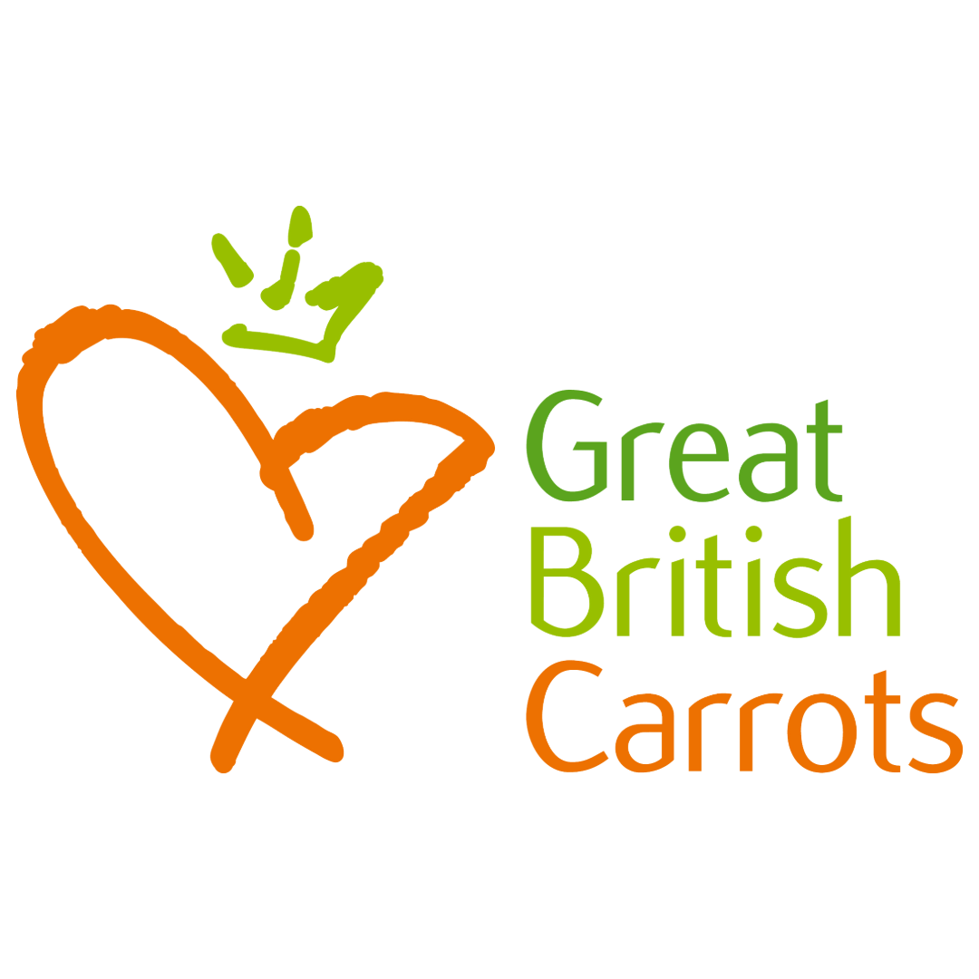 **LISTICLES**

**FOOD**

**Pimp up your carrots – 7 ways with carrots**

1. Roast with honey and cumin
2. Mash with butter and chopped parsley
3. Use a peeler to make strips to add to salads and stir fries
4. Grill or barbecue and top with toasted sunflower seeds, pinenuts or pistachios and serve on a bed of soft cheese such as mascarpone. Got the tops? Blitz them into a pesto.
5. Dip with hummus for a fibre-protein combo that’s good for gut health
6. Grate and mix with raisins, apples, orange juice and olive oil
7. Sprialise and smother in your favourite pasta sauce

**TOP TIP:** Colour me happy - carrots come in all colours to jazz up your dishes: **Rainbow** offers a colourful mix of orange, yellow, white, pink, and purple carrots; perfect for adding visual zing to salads. **Chioggia**, an Italian heirloom variety, is strikingly red-and-white striped. **Nantes** is an orange old French variety that combines crunchiness with a mild, sweet taste.

**HEALTH**

**The Orange Powerhouse: 5 ways carrots are the tops when it comes to health**

1. **Carrots have 2g of fibre per carrot** – munching a few gets you well on the way to the recommended daily intake of 30g of fibre, great for your gut
2. **The retinol revolution starts in your vegetable drawer** - Beta-carotene is the stand-out nutrient in carrots – our bodies convert it into retinol, which is the active form of Vitamin A that supports eye health (can you see in the dark?), skin health and our immune system.
3. **Munching carrots raw is good for your mouth** - and oral health – munching carrots stimulates saliva which neutralises harmful acids produced by bacteria, and Vitamin A maintains mucus membranes in the mouth. The thick texture of carrots naturally breaks apart the plaque and tartar on your teeth.
4. **Swap in a carrot to snack time** - Carrots are 80% water, with just 5% sugar – low, natural sweetness with plenty of crunch. A large carrot has 61% less sugar (4.7g compared to 12.2g per 100g) than a banana and 54% less calories, along with 58% less carbohydrates and wins hands down when it comes to Vitamin A content, 277 times more to be exact.
5. **Carrots are a healthy, low-fat dog treat** - great for helping to keep plaque away from your pup’s teeth

**TOP TIP:** Muddy carrots stay fresh for longer and can be kept in a dry, dark place like a kitchen cupboard. To keep ready-washed carrots fresher longer, remove from the packaging, wrap in kitchen roll and store in the fridge.

**FARMING**  
**A mighty bunch – 9 facts about farm fresh carrots**

1. **Britain produces over 700,000 tonnes of carrots** each year - that’s the weight of 70 Eiffel Towers - around 100 each for every member of the population
2. **Carrots are harvested all year round** so they are always fresh from the field starting earlier in the year with southern regions and moving up the country from Kent to the north of Scotland.
3. **The first recorded carrots weren’t orange** – believed to have originated in Afghanistan in 7th Century AD – carrots were purple or yellow, with orange developed in the 16th century in Holland.
4. **To keep them cosy** over winter and free from frost, carrots are covered with beds of straw
5. **Carrots like fresh soil and a new place to grow each year**. To protect them from disease, carrots can only be grown in the same field once every seven years, so farmers ‘rotate’ them around their farm
6. **A love medicine:** The Greeks called the carrot “Philtron” and used it as a love medicine
7. **Carrots like sandy soils, growing wonky if the land is stony.**
8. A lot of research, innovation and technology goes into growing the best carrots in the UK, from making sure the seed grows well in the soils we have, to improve nutrient value - today’s carrots have 50% more carotene that those of 1970 – and to make sure they last well on shop shelves. GPS is used in tractors to plant the carrots perfectly straight lines and robots are used for weeding and sorting
9. **Carrots are worth £290 million** to the UK economy – but one of the cheapest veg to buy

**COOK AND SHARE ON SOCIALS**

**Eat carrots at every meal this British Carrot Day**

**From breakfast to lunch and supper, you can eat carrots at every meal on Friday 3rd October. Share your photos #lovebritishcarrots #BritishCarrotDay25**

**Whether you're crunching or cooking, here’s why this humble veg deserves the spotlight this autumn:**

1. **Morning glory:** Overnight carrot cake oats – sweet, spiced and ready when you wake up.
2. **Lunchtime legends:** Fresh, zesty carrot salad – light, crisp and full of colour.
3. **Dinner stars:** Brush with oil and put whole carrots under the grill or on the firepit, lay over a spread of mascarpone, top with pine nuts and add a drizzle of honey or balsamic glaze. Got the leaves too? Blitz the green tops into a pesto to finish it off.
4. **Sweet treats** for afters or in between: carrot cake, carrot muffins, carrot flapjack or carrot ice cream

Dr Laura Wyness, RNutr shares the first two recipes in our social media toolkit here <https://drive.google.com/file/d/1gdwcGZb1S2Fu7ROAtLsBYT0-f0M-ASnW/view?usp=sharing>

For more information, including more recipe ideas, visit [www.britishcarrots.co.uk](https://www.britishcarrots.co.uk)

**Resources and references**

<https://www.allpetsvets.co.uk/article/richard-breaks-down-carrots-dental-hero-or-just-a-snack/>

<https://snodgrassking.com/why-carrots-are-beneficial-for-oral-health/>

The British Carrot Growers Association:

[www.britishcarrots.co.uk](https://www.britishcarrots.co.uk)

Dr Laura Wyness, award winning Registered Nutritionist:

<https://www.laurawyness.com/>

Clare MacLeod, Independent Registered Equine Nutritionist

<https://www.equinenutritionist.com/>

The World Carrot Museum: <https://web.archive.org/web/20220802094657/https://www.carrotmuseum.co.uk/index.html>

<https://www.vogue.com/article/carrot-salad-skin>