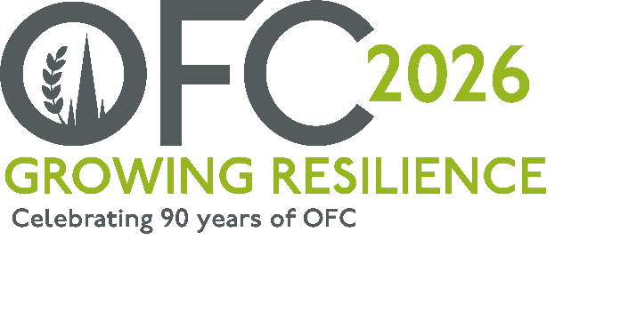

PRESS RELEASE
For immediate use
Date: 05/08/2025

Inviting the agricultural sector to be Inspired.
The Oxford Farming Conference (OFC) has opened applications for Inspire, a programme designed to support food and farming professionals to develop their skills and network.
Created to enable ambitious candidates across the rural and agri-food sector to attend OFC for the first time, the programme has led to career changes and progression, new businesses, collaborations and opportunities for many of the graduates.
The 2026 Inspire Programme will be managed by OFC Director David Hill, a graduate of the Inspire Programme and Estate Manager.
“Inspire has developed a reputation for encouraging excellent people in the farming and food sector and giving them the push and confidence to do things that they might not otherwise have done. As is the way with the conference, Inspire brings people together and great things start to happen. You just have to apply and be open to the opportunities.”
Ben Eagle took part in the programme in 2024, and feels it provided a platform for him to reassess his future plans.
“From networking opportunities to personal reflection, the programme gave me the time and space to reflect on my next steps, as well as connect with a brilliant group of leaders, representing diverse areas of the agricultural industry, bringing a wide range of views and discussions, but all within a safe and welcoming environment. I’d encourage anyone to apply; it is a real catalyst for change and a unique experience.”
In addition to time at the conference, the group receives support from industry bodies and professionals, including programme partners BASF Agricultural Solutions and The Institute for Agriculture and Horticulture (TIAH).
Commenting on the programme, Alice Johnston, Agricultural Sustainability Manager from BASF said,
“At BASF, we are deeply committed to the long-term success and sustainability of UK agriculture. We recognise that the many challenges facing our industry, whether environmental, economic, or social, require bold thinking, diverse perspectives, and strong collaboration across the entire agricultural ecosystem.
"That’s why we’re proud to continue supporting the Inspire Programme alongside TIAH, an initiative that not only nurtures emerging talent but fosters innovation, leadership, and resilience within the sector.
“By investing in the next generation of agricultural changemakers, we’re helping to ensure that our industry continues to evolve, adapt, and thrive in the face of change.”
Tess Howe from TIAH added,
“We’re proud to sponsor OFC Inspire for the fourth year, supporting opportunities for learning, connection, and personal growth, values at the heart of TIAH. By helping participants discover their potential and make an impact in their careers, we’re investing in the future of our industry. We look forward to meeting this year’s delegates and seeing how they develop, contribute, and help shape agriculture’s next chapter.”
The programme includes two pre-conference Inspire Days in London in November, a full ticket to the 2026 Oxford Farming Conference from 7 to 9 January 2026, themed “Growing Resilience” including accommodation, Chair’s Welcome Reception, Christ Church Dinner and the OFC Oxford Union Debate, and the opportunity to join a network of over 115 alumni who continue to connect and network post OFC.
Applications are open until 27 August 2025. To find out more and apply, visit www.ofc.org.uk
-ENDS-

Notes to Editors:
For more information on the Oxford Farming Conference (OFC):
Website: www.ofc.org.uk
Twitter: @oxfordfarming
YouTube: OxfordFarmingConference
- The OFC is one of the only external events to be allowed to host a debate in the Oxford Union. It has a long and proud history going back to 1936 and a strong reputation as one of the UK’s leading agricultural events. It always takes place in Oxford in the first week of January and is based at the Oxford Examination Schools. It offers a vibrant programme of speakers, panel and politics sessions as well as networking.
- OFC is a charity that invests in agricultural education and knowledge-sharing. It attracts over 650 delegates every year, including many people from the wider food chain, retail, NGOs, scientific organisations, media, policy-making bodies and governments from around the world.
- HRH Princess Royal is patron of the OFC.
- OFC 2026 will take place from 7th - 9th January 2026 and will mark 90 years since the launch of the charity.
- The OFC 2026 Chair is Jude McCann and will be themed “Growing Resilience”

