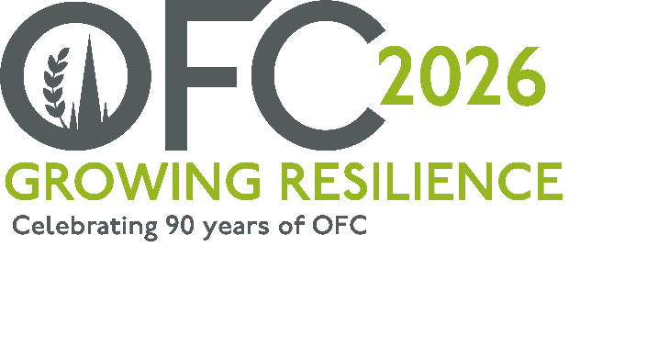
PRESS RELEASE
For immediate release
01 August 2025
Growing Resilience: A positive future for UK agriculture
The Oxford Farming Conference’s (OFC) new Chairman has shared plans for the charities 90th anniversary, with a focus on challenging the status quo, and driving a positive movement for change within UK agriculture, and beyond.
Jude McCann, the OFC’s 2026 Chair and CEO of the Farming Community Network (FCN) described that the theme, “Growing Resilience”, will unite speakers and delegates from a wide geography, to demonstrate and debate how sectoral risk, and future shocks could be managed to revolutionise agriculture.
Commenting on the event, taking place from 7 to 9 January 2026, Jude said,
“As we celebrate 90 years, we have a chance to reflect on previous generations, and at times, it could be argued they were more resilient. There were more mixed farming businesses, a higher proportion of people working on the land, and less complexity when it came to legislation. However, as a sector, over the decades we have always adapted to the changes required to ensure we continue to produce food in a safe and sustainable manner, with a greater emphasis on social and environmental transformation.
“The 2026 conference will reflect on some of this change with a strong focus on looking forward to the future. With three core themes running throughout the agenda – people, the environment and business – the event will look to encompass policy, trade, climate, family farming, production, adoption of innovation and advancements of technology, to name just a few topics.
“We will highlight connectivity, through human and mechanical interactions. We will explore mindset, financial resilience, and as always, we will provide platforms and space for healthy debate and discussion, allowing all views to be shared.”
As one of the only external events with permission to use Oxford University’s prestigious Oxford Union Debating Chamber, the 2026 OFC debaters will join notable historical leaders, including Winston Churchill, Albert Einstein and Ronald Reagan, the OFC’s Oxford Union Debate will bring a theatrical discussion that will consider how farming businesses might operate in the future, creating a pathway for new thinking.
Also returning for 2026 and kindly supported by the Frank Parkinson Agricultural Trust who have been supporting the conference for 25 years, will be the OFC report. This will focus on agriculture’s future opportunities, providing insights and recommendations gathered from both the UK and across the world, exploring how the sector can benefit and grow its resilience, The premiss for the report and the wider conference is how UK Agriculture might evolve into a mission-led, agile and opportunity driven industry, with people that can adapt to embrace the future.
Jude, who grew up on his family’s farm in Mid-Ulster, has lived and worked in the UK and New Zealand, and has a strong understanding of the challenges facing agriculture. After spending seven years at CEO for Rural Support, a charity in Northern Ireland assisting farmers and their families, he was appointed CEO with the Farming Community Network (FCN) in 2020 and now works across the UK supporting farming families. He joined OFC as a Director of the charity in 2023, and was recently appointed Chairman, to lead the 2026 conference.
“I attended by first OFC in 2020 and was struck by the way the event creates a sense of community, a tribe of people who want to collaborate and make a real difference,” he said.
“We know there are many challenges facing agriculture, but it is important, where we can, to look for hope and optimism. OFC is unique, not only in terms of the exclusive venues it uses and renowned networking, but its approach to offer a programme that demonstrates people with solution-led insights and stories, driving positivity and optimism for the future.”
Tickets are now on sale for Growing Resilience, taking place from 7 to 9 January 2026 at www.ofc.org.uk.
The 2026 Partnership Programme is also live for organisations and businesses wishing to get involved in the event. More information can be found on the website.
-ENDS-
Notes to Editors:
For more information on the Oxford Farming Conference (OFC):
Website: www.ofc.org.uk
Twitter: @oxfordfarming
YouTube: OxfordFarmingConference
- The OFC is one of the only external events to be allowed to host a debate in the Oxford Union. It has a long and proud history going back to 1936 and a strong reputation as one of the UK’s leading agricultural events. It always takes place in Oxford in the first week of January and is based at the Oxford Examination Schools. It offers a vibrant programme of speakers, panel and politics sessions as well as networking.
- OFC is a charity that invests in agricultural education and knowledge-sharing. It attracts over 650 delegates every year, including many people from the wider food chain, retail, NGOs, scientific organisations, media, policy-making bodies and governments from around the world.
- HRH Princess Royal is patron of the OFC.
- OFC 2026 will take place from 7th - 9th January 2026 and will mark 90 years since the launch of the charity.
- The OFC 2026 Chair is Jude McCann and will be themed “Growing Resilience”

