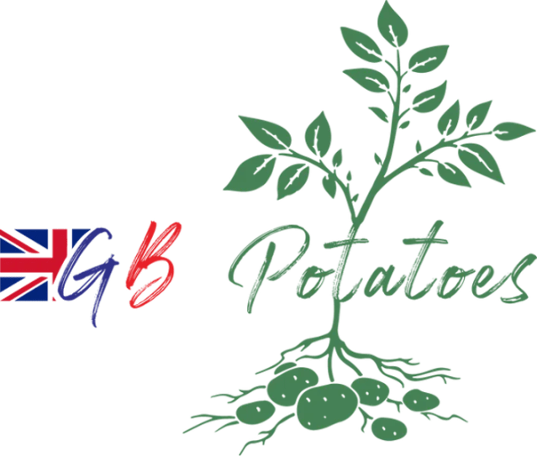

**Press Release**

24 July 2025

**New industry development programme looks to cultivate the future of the potato industry.**

GB Potatoes, in association with the British Potato Trade Association (BPTA), has launched a new initiative to support the skills and knowledge development of future growers, leaders and industry experts.

Supporting individuals from seed production to the end of the supply chain, the Potato Industry Development Programme is designed for new entrants to gain a comprehensive understanding of the sector, while building valuable networks and collaborations.

Taking place throughout 2026, the programme will be delivered in three phases, incorporating research and development, growing, processing and production, policy and communications.

Participants will get the chance to visit leading brands within the industry including McCains, Branston and Pipers Crisps as part of the first session, hosted in February 2026.

The second phase in June 2026, will include visits to the Science and Advice for Scottish Agriculture (SASA), mini tuber facility with Cygnet, grower Robert Doig, machinery manufacturer Scanstone and the James Hutton Institute, where the European Potato collective is housed.

A final session in London, in November 2026, will provide insight into how and why lobbying bodies engage with government, and the role that the next generation can play in supporting and influencing future decision making.

Commenting on the programme, GB Potatoes Chair Alex Godfrey said, *“Since the Next Generation Programme, run by AHDB, came to an end, there has been no specific, industry wide training for new entrants and those developing their careers within the potato sector. With a current lack of training for new entrants within the potato industry, GB Potatoes has recognised the need to develop an initiative that supports the growth of our future leaders, building connections, knowledge and optimism within our industry.*

“*With continuous change impacting our sector, from new technological advancements to extreme weather events, it is more important than ever that we create opportunities for the next generation to develop their understanding of how we can be resilient when it comes to growing our crops, efficient in processing and packaging, and developing strong messages that resonate with the consumer*.

“*I am, therefore, delighted that alongside the British Potato Trade Association we can offer this incredible opportunity, and I would encourage anyone at the start of their career to apply – you never know where it might lead*.”

The cost for the programme, which includes all accommodation, meals and minibus travel during the trips, is £1000 for GB Potatoes members, or £1500 for non-members. Places are limited and those interested in applying should visit the GB Potatoes website to complete the short application form at <https://www.gb-potatoes.co.uk/news/>

Applications close on 12th September 2025.

For any questions about the programme, please contact Graham Bannister, via gb@grahambannister.co.uk

-Ends-

**Media and Press**: Rebecca Dawes – [rebecca@janecraigie.com](mailto:rebecca@janecraigie.com) – 07792 467730

**Notes to editors**

**About GB Potatoes** - GB Potatoes was established in May 2022 to fill the void after the AHDB potato levy board ceased to exist, leaving the potato industry without a unified sector focused representation. It aims to provide a cohesive and impactful voice for the sector, encouraging participation from the whole potato supply chain including growers, packers, processors, seed growers, researchers, advisors, and ancillary businesses. Membership is open to anyone in the sector.

**The Potato Industry Development Programme –** an outline of the programme can be found below.

Session 1. English visits, 2nd to 4th February 2026,

* + Tour of McCains
  + QC/QA understanding
  + Requirements for a processing crop.
  + Integrating the processing supply chain.
  + Visit to Branston.
  + Requirements for fresh production
  + QC and QA awareness
  + Integrating the fresh supply chain.
  + Visit to machinery manufacturer, Haith.
  + Visit to AKP
  + Storage, trading, grading
  + Visit Pipers crisps

Session 2. Scottish visits, 9th to 11th June 2026

* + SASA (Edinburgh
  + Understanding seed certification, classification and regulation, in conjunction with BPTA
  + Nuclear stocks.
  + PCN & virus testing.
  + Tuber inspection - BPTA
  + Visit to Cygnet for mini tuber production.
  + Visit Robert Doig, high grade and commercial seed production.
  + Visit machinery manufacturer. Scanstone
  + Visit The James Hutton Institute.
    - European Potato Collection
    - Breeding
    - Virus
    - PCN
    - Blight
    - NPIC

Session 3. London visit, November 2026

* + Visit Westminster
  + NFU
  + MPs