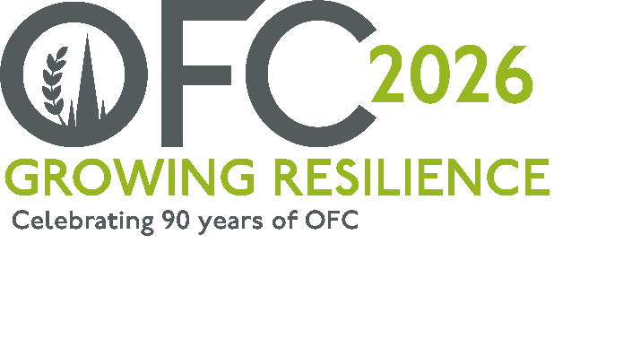
PRESS RELEASE
DRAFT
27 May 2024
Oxford Farming Conference calls for new Directors, as the charity celebrates 90 years.
The Oxford Farming Conference (OFC) has opened applications for three new individuals to join the board and support the future development of one of the UK’s most renowned agricultural events.
Launched in 1936, OFC is known for its high calibre of speakers, international perspectives, broad thinking, exceptional networking, and significant political and societal announcements, shaping the future direction of UK agriculture.
It is also one of the only events out with the Oxford University to use prestigious venues such as Christchurch College and the Oxford Union Debating Chamber, which has welcomed notable figures in history, including Winston Churchill, Albert Einstein and Ronald Reagan.
The 2026 event (7 – 9 January), which will celebrate the 90th anniversary of OFC, will be themed “Growing Resilience”, led by Chair and CEO of the Farming Community Network, Jude McCann. Commenting on the Director Recruitment, Jude said,
“The Oxford Farming Conference offers a unique chance to build your skills and experiences, whilst also giving back to a charity that is dedicated to supporting the future of agriculture.
“Over the last 90 years, our predecessors have delivered an event that has often marked a significant change in the industry, from key political announcements about funding and regulations, to societal change of inclusion and diversity, through to business diversifications, practical on-farm solutions, and international trade.
“As we look forward to the next 90 years of OFC, we seek to appoint three new Directors who will join our board for a three-year term, collaborating and developing new themes, sessions and speakers for the forthcoming conferences.”
Current Directors include CEO of Niab, Mario Caccamo, Project Manager (Rural) for Scottish Enterprise Julia Latto, Estate Manager, David Hill, Savills Director and Head of Rural Research Kelly Hewson-Fisher and Sustainability Manager for Leprino Foods, Ben Williams.
To find out more about the Director Recruitment, view the full board, and download the application form, visit www.ofc.org.uk. Applications close on 25 June 2025.
-ENDS-
Notes to Editors:
For more information on the Oxford Farming Conference (OFC):
Website: www.ofc.org.uk
Twitter: @oxfordfarming
YouTube: OxfordFarmingConference
- The OFC is one of the only external events to be allowed to host a debate in the Oxford Union. It has a long and proud history going back to 1936 and a strong reputation as one of the UK’s leading agricultural events. It always takes place in Oxford in the first week of January and is based at the Oxford Examination Schools. It offers a vibrant programme of speakers, panel and politics sessions as well as networking.
- OFC is a charity that invests in agricultural education and knowledge-sharing. It attracts over 650 delegates every year, including many people from the wider food chain, retail, NGOs, scientific organisations, media, policy-making bodies and governments from around the world.
- HRH Princess Royal is patron of the OFC.
- OFC 2026 will take place from 7th - 9th January 2026 and will mark 90 years since the launch of the charity.
- The OFC 2026 Chair is Jude McCann and will be themed “Growing Resilience”

