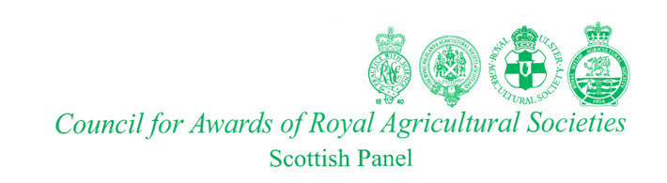

**PRESS RELEASE**

**Bill Gray MBE New Chair of CARAS Scotland**

**CARAS the body honouring distinguished service to Scottish agriculture and related sectors has a new Chair. Well respected Midlothian farm and estate manager Bill Gray MBE was appointed at their recent Conference and AGM held at the Royal Highland centre, Ingliston. He succeeds Stranraer farmer Robert Parker.**

**The men and woman who are Associates and Fellows of the Royal Agricultural Societies are nominated and selected for their outstanding contribution to UK agriculture and rural prosperity. Members include engineers, researchers and communicators as well as those more directly involved in all aspects of land management.**

**Bill Gray is well known for his prominent part in guiding the Royal Highland Society through a difficult period of the Covid restrictions when the Highland Show was first cancelled then successfully relaunched without the paying public. Following his appointment as Chair of the Scottish CARAS panel Bill said.**

***“I am proud and delighted to have been elected to the CARAS Scotland Chair. It is an honour to lead this organisation for the next two years and I look forward to recognising and celebrating excellent achievement in our agricultural and related industries and to represent the Scottish panel at our sister Royal Agricultural Societies. I would also like to pay tribute to our outgoing Chair, Robert Parker for his outstanding stewardship of the past two years.”***

**Bill Gray’s new role wasn’t the only change within the CARAS organisation in Scotland. Unanimously approved as Secretary was Aberdeenshire’s Janelle Anderson. She had been the first ever female Chair of the Royal Northern Agricultural Society and is presently N Region Manager of the Scottish Association of Young Farmers Clubs.**

**If the CARAS Scotland panel considers a nomination from Fellows or Associates is worthy of progress they invite candidates to apply, submitting details of their activities after which two assessors interview them. The awarding of Certificates of Associateship or Fellowship normally take place at the Royal Highland Show. The process is also followed in England, Wales and N. Ireland.**

Ken Rundle (Press Liaison CARAS),

136 Blenheim Place,

Aberdeen.

AB25 2DN

07710 079401

**krundle009@gmail.com**