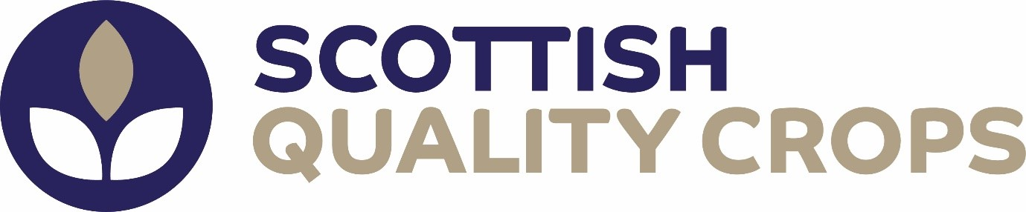

PRESS RELEASE
26.01.2024
New Chair for quality assurance for Scotland’s crops
Fife arable farmer, John Hutcheson, has been appointed the new Chair of the Board for Scottish Quality Crops (SQC), Scotland’s quality assurance scheme for combinable crops, alongside new Vice Chair Mark McCallum.
John farms an extensive arable unit, growing cereals and oats in West Fife. He brings with him varied experience and perspective from running his own farming enterprise as well as his roles as Chair of Scottish Agricultural Organisation Society (SAOS), Chairman of Oat Co Group, a cooperative for oat growers in Scotland and the single largest supplier of Milling Oats into Quaker, and is a former Chairman of Tayforth Machinery Ring.
SQC, which was first established in 1994 and provides quality assurance for grain markets, is streamlined to have just one part-time employee, the Managing Director. Being underpinned by an experienced Board with strong leadership is critical to the success of SQC and ongoing support to our members, says current Managing Director, Teresa Dougall:
“We are looking forward to John and Mark taking the helm of the Board and leading SQC through its next phase of both opportunity and challenge. There is plenty of change and progress in our sector and we welcome the experience and insights they will bring as we ensure our assurance scheme remains fit for purpose and continues to secure access to the widest and most lucrative markets for our farmer members.”
Teresa also thanked outgoing Chair, Andrew Moir, arable farmer and industry stalwart, who has steered the board for the last eight years. Andrew has also been Chair of AgriScot and of Ringlink, and steered the Farmer Led Group for Arable:
“We’ve greatly valued Andrew’s expertise and insights from working across the industry with NFUS, the Voluntary Initiative and other related posts, as well as his ground-up perspective as an arable farmer. I have also personally gained from his generous support and guidance when I took on the role as Managing Director at a time of significant change, including appointing a new certification body and the impact of Brexit and policy changes on maintaining fluid market access. I’d also like to congratulate Andrew on being awarded this year’s Ed Rainy Brown Award from SAOS in recognition of his many years of co-operation and collaboration within the agricultural industry. It’s very well deserved, and we wish him all the very best for the next chapter.”
Andrew was also involved, with Teresa and the Board, in undertaking a full review of the standards and creating a Scottish Crops Supply Chain Hub. This cross-sector group provides an interface with the industry on important issues and has proved a valuable mechanism for specialist constructive feedback from across the cereals supply chain to ensure the standards remain relevant.
Mark McCallum, who will take up the role as SQC Vice Chair, farms an arable enterprise comprising of the home farm and a number of contract farming agreements between Dingwall and Cromarty on the Black Isle. He is a former Chairman of the grain cooperative, Highland Grain, as well as growing for the coop, and, as current NFUS Regional Chair for the Highlands, will be one of the NFUS representatives on the SQC Board, which is made up of representatives from seven industry organisations.
The SQC assurance scheme was founded in 1994 as Scottish Quality Cereals, to give cereal producers the opportunity to place Scotland's cereals at the premium end of the UK and European markets. Changing its name to Scottish Quality Crops in 2007 to encompass all combinable crops, in 2020 the company became a stakeholder co-operative to maximise expertise and collaboration opportunities across the sector.
John, who has been integral within the SQC Board for some time, says he is looking forward to continuing to strengthen SQC and its offering to farmer members and stakeholders:
“Quality Assurance and traceability, and increasingly evidence of sustainable farming practices, is essential for customers and the supply chain. SQC’s overarching goal is to help growers gain market access and premiums for their crops by providing this. This is by ensuring that the standards meet the requirements of the widest and best markets, but it is also supporting growers through the audit process, taking a pragmatic approach to quality standards, streamlining and leveraging technology where we can, and continuing to place the farmer at the heart of the organisation."

