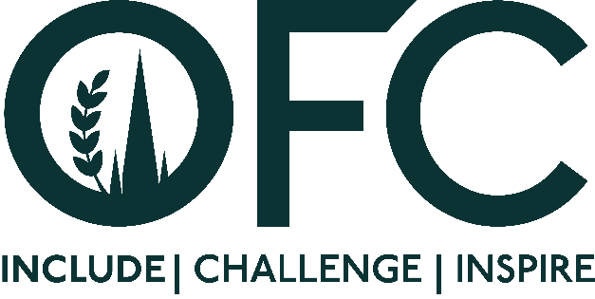
Press Release
[21 November 2023]

OFC continues to Inspire.

More than 100 individuals have now completed the OFC Inspire Programme, supporting their personal and business growth through skills development and networking.

The success of the initiative, run by the Oxford Farming Conference (OFC), has resulted in career changes, charitable appointments, new enterprises, and leadership roles for several of the alumni. This includes the current OFC Chairman Will Evans, who completed the programme in 2018.

Following this success, OFC, with support from The Institute for Agriculture and Horticulture (TIAH) has announced 14 new individuals who will join Inspire as part of OFC 2024, themed, “The Power of Diversity”. Aged between 30 and 45 years old, all candidates are actively involved in the rural, food and farming sector.

They include livestock, dairy and arable farmers, agronomists, nutritionists, knowledge exchange fellows, marketers, communicators and show society managers.

Commenting on the programme, OFC Director and 2024 Programme lead, Geoff Sansome said,

“OFC is more than a conference, our outreach programmes including Inspire, Scholars and Breaking Barriers’ scholarships, provide crucial opportunities for ambitious individuals to discuss, debate and inform their own thinking in a safe environment, whilst also generating new networks and contacts to support their future, and ultimate that of our agricultural and rural sector. The success of Inspire over the last five years demonstrates its positive impact, and the lasting legacy the experience and connections gained once candidates complete the programme.”

Tess Howe, Head of Partnerships and Membership at TIAH added,

“We’re very pleased to be sponsoring the OFC Inspire programme for the third year running. Inspire does what it says on the tin, it inspires participants to push themselves and their career forward by taking part in a range of development and networking opportunities – an aim which strongly aligns with TIAH’s goals. Over the last two years we have seen those who have taken part in the programme grow in confidence and go from strength to strength. We’re looking forward to supporting the next group of Inspire delegates to achieve the same success.”

This year’s Inspire programme started in early November with a pre-event meeting in London where the group were joined by Chair of Natural England, Tony Juniper and the Chief Executive of the Food, Farming and Countryside Commission, Sue Pritchard, who discussed imposter syndrome, making the most of your networks and developing your leadership journey.

This was followed by a visit to the New Zealand Embassy, hosted by Hillary Curnow, Counsellor for the New Zealand Minister of Foreign Affairs and Trade. This provided discussion on trade and opportunities between the UK and New Zealand, as well as the opportunities that could face the two countries in the future.

The group will now attend OFC from 3 to 5 January 2024, in Oxford where more than 40 speakers will take to the stage to discuss diversity in all forms – business, land, environment, income and people.

To find out more about the conference visit www.ofc.org.uk

ENDS

Issued by Jane Craigie Marketing. For further details or interviews, please contact marketing@ofc.org.uk or 07792 467730

2024 Inspire Candidates

Sarah | Alderton | Cumbria | Freelance Farming Journalist and PR Consultant
Saba | Amir | Shropshire | Knowledge Exchange Fellow, Farming Connect
Sam | Brook | West Sussex | Senior Agronomist, Vitacress Herbs
Andrew | Court | Staffordshire | Farmer
Ben | Eagle | Norfolk | Rural Affairs Podcast Producer and Journalist
Ruth | Grice | Leicestershire | Partner, Family Dairy Farm
Sophie | James | Somerset | General Manager, Davidstow Creamery Direct
Michael | Kavanagh | Shropshire | Farm Manager
Alana | McLean | Aberdeenshire | Communications Manager (Press and Media), Food Standards Scotland
Robyn | Munt | Isle of Wight | Independent Farm Consultant and Facilitator
Henry | Reynolds | Northamptonshire | Independent Agricultural and Engineering Consultant
Emma | Smith | Herefordshire | Trainee Agronomist, Agrii
David | Tennant | Midlothian | Head of Show, Royal Highland and Agricultural Society of Scotland
Karen | Wonnacott | Devon | Secretary, Dairy Science Forum

Notes to Editors:

- For more information on the Oxford Farming Conference (OFC):
Website: www.ofc.org.uk
Twitter: @oxfordfarming
YouTube: OxfordFarmingConference

- The OFC is one of the only external events to be allowed to host a debate in the Oxford Union. It has a long and proud history going back to 1936 and a strong reputation as one of the UK’s leading agricultural events. It always takes place in Oxford in the first week of January and is based at the Oxford Examination Schools. It offers a vibrant programme of speakers, panel and politics sessions as well as networking.
- OFC is a charity that invests in agricultural education and knowledge-sharing. It attracts over 650 delegates every year, including many people from the wider food chain, retail, NGOs, scientific organisations, media, policy-making bodies and governments from around the world.

- HRH Princess Royal is patron of the OFC.

