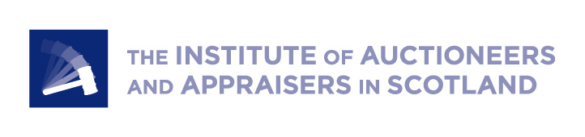

PRESS RELEASE
25.9.23
150 lambs needed to reach Lamb Bank target

Over 24,000 school children are signed up to Lamb for St Andrew’s Day, the initiative from the industry that aims to encourage more people to cook, eat and enjoy lamb as part of the Patron Saint’s celebrations.

To inspire the next generation, Scotland’s Institute for livestock marts and auctioneers, IAAS, started The Lamb Bank three years ago to gather donations from the industry to give lamb to schools, for free, for use on the 30 November. Over 390 lambs and 65,000 lamb portions have been donated over the last three years for school canteens and Home Economics classes across Scotland.

“There is just no better way to tell the story of lamb and encourage more people to choose it from shop shelves or when eating out than to give them first-hand experience of eating and cooking it,” says Neil Wilson, Executive Director of IAAS. “School teachers have loved the opportunity to inspire young people with tasty, fun-to-make recipes and the chance to try lamb, whether it’s in class or the canteen. It’s a hugely valuable and interactive way to teach about the merits of Scottish lamb production and healthy eating and to counter negative marketing around red meat, but also to demonstrate that it can be affordable.”

As the appetite among schools grows to be part of this, IAAS is urgently calling on the industry to donate, whether it’s the value of a lamb at the next mart sale, or financial donations from other farmers or agricultural organisations who would like to support the future of lamb production in Scotland.

“If we all put in a little, it spreads the burden, and we are calling on everyone, mart users or not, to come forward and give what they can so we can make a big impression.”

Just 150 lambs are needed to reach this year’s target of delivering 2.75 tonnes of lamb into 24,000 school children this November. This can be done by donating the value of store, prime and breeding lambs, cull and breeding ewes and tups, usually in the region of £100-£150, via any Scottish auction market.

Auctioneers will also be giving customers the opportunity to make financial donations for similar amounts over the phone when they are speaking to them, and industry organisations and individuals can donate directly by contacting IAAS or at Ko-Fi (www.ko-fi.com/iaaslambbank). One portion is £1.75 delivered, so a donation of just £35 will give 20 school children a chance to try lamb this November.

In 2022, IAAS worked with 43 independent butchers to process and pack the lamb for schools, with volunteers delivering across the country. Woodhead Brothers in Turriff donated lamb for 1,880 Aberdeenshire school children, delivered by G & M Whyte, Munro’s in Dingwall supplied the Highlands and the Western Isles, while Shetland Livestock Marketing Group covered all Shetland schools and their 160 pupils.

QMS is working closely with IAAS and livestock auctioneers to support the Lamb Bank again this year by helping develop exciting recipes for children to cook with in Home Economics classes. The team is also promoting the campaign acroso social media and advertising channels. Its Health and Education team has created lesson plans, worksheets and PowerPoint presentations, produced in line with the school curriculum, supporting teachers to tell the story of seasonal and sustainable lamb production in Scotland, the positive environmental aspects of grazing and the health and nutritional benefits of the meat.

Lamb for St Andrew’s Day has been recognised in the Scottish Parliament and has become one of the key lamb promotion events in Scotland. It is credited for supporting and improving the prime lamb price throughout the month of November with the price tracking upwards during the month over the last three years.

Editor’s Notes

*Additional funds raised will be used to supplement the administrative, butchery and delivery costs. Most of these are already covered by IAAS members.

