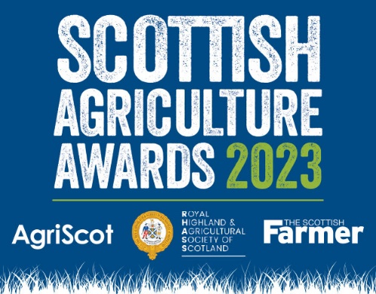

PRESS RELEASE
27.10.23
Final

Leading Farming Businesses And People Celebrated in Inaugural Scottish Agriculture Awards

Last night (Thursday 26th October), the inaugural Scottish Agriculture Awards took place welcoming over 450 people to celebrate some of the most innovative and progressive agricultural business and individuals within the sector.

Hosted by three leading organisations in the industry, AgriScot, Royal Highland & Agricultural Society of Scotland (RHASS), and The Scottish Farmer, the evening included 13 categories from advisor and machinery dealer, through to the long-standing and well-regarded Farm of the Year awards.

Compered by The Sheep Game’s Cammy Wilson, the Unsung Hero, sponsored by Virgin Money, was awarded to John Copland from Orkney who has dedicated 46 years of his life as an auctioneer, firstly at Kirkwall Auction Mart and latterly the Orkney Mart, where he had been the backbone of some of the island’s biggest changes and improvements to its agricultural industry.

A special Lifetime Achievement award opened the ceremony and was presented to editor and journalist Ken Fletcher who has committed more than 50 years of his life to writing and editing stories and news for the Scottish Farmer.

The top award, Champion of Champions sponsored by ScottishPower Renewables, went to the Diversified Farm of the Year, Glenklin Farm in Arran, run by the Bone Family. The judges commended the family’s commitment to the community, and their ambition to continue to develop and improve the farm for future generations.

On the evening, AgriScot Chairman Robert Neil welcomed guests and said,
“I would like to congratulate all of the finalists for these awards. We are proud to be part of this collaboration to create these all-encompassing Scottish Agriculture Awards that give recognition across the breadth and depth of the agricultural industry and throughout the regions of Scotland. Every part of the industry relies on each other to keep the whole sector thriving.”
Chairman of the Royal Highland Agricultural Society of Scotland, Jim Warnock added:
“We gather here not only to celebrate the first Scottish Agricultural Awards but also to honour the unwavering dedication and hard work of those who work on our farms and in the industry day in and day out. Tonight, we have witnessed the remarkable talent, innovative spirit, and outstanding contributions to Scottish agriculture, and it is truly inspiring.

“I want to extend our gratitude to the nominees and award winners. Your relentless efforts, passion for farming and agriculture, and determination to excel have earned you these accolades and set high standards for all of those working across Scotland. Your achievements are a testament to what can be accomplished when passion meets perseverance.”

The Scottish Agriculture Awards have been established by AgriScot, RHASS, as headline sponsor, and the Scottish Farmer to centralise into one flagship event and complement their own awards that take place at the Royal Highland Show in June and AgriScot in November each year.
The first AgriScot award was Dairy Farm of the Year in 2009, followed in subsequent years by new categories for beef, sheep, arable and, in 2021 Diversified farm of the Year. New for 2023 is Sustainable Farm of the Year to recognise the positive work being done by farmers as the industry is adapting and responding to new legislation, environmental concerns and consumer demands.
John Sleigh, Editor of the Scottish Farmer, said:

“The evening celebrated the spectrum of our industry, from small one-farmer units producing the best of cattle and sheep from Scottish grown grass to cutting edge agri-businesses who are using the latest precision technology to feed the population of tomorrow. Our finalists are categorical proof that Scotland is up there with any other sector on the globe.

“You can just feel the sizzling talent from our sector at the moment. We are at a very special time. This and the next generation is going to drive our industry forward like never before.”

The evening, held in Glasgow, included a three-course meal showcasing some of the finest Scottish ingredients and live music.

For photographs of the winners, please click here.

A copy of this press release can be downloaded here.

WINNERS:

Adviser of the Year
Heather Wildman, Saviour Associates Ltd

Animal Health Provider of the Year
Clyde Vet Group

Best Agroforestry Award sponsored by Field & Forest
W. Laird & Sons, Netherurd Home Farm

Machinery Dealer of the Year
C T Scott LTD

Supplier of the Year
Redpath Tyres

Young Farmer Initiative of the Year
SAYFC & RSABI - Development and Wellbeing Committee, Thrive Mental Wellbeing App Pilot

Arable Farm of the Year sponsored by soilessentials
Savock Farms, Aberdeenshire

Dairy Farm of the Year Award sponsored by GEA
Coopon Carse Farm, Dumfries and Galloway

Diversified Farm of the Year sponsored by SAC Consulting
Glenkiln Farm, Arran

Scotch Beef Farm of the Year sponsored by ABP
Firm of T Hodge, Rulesmains Farm, Scottish Borders

Sheep Farm of the Year sponsored by Thorntons Law
Windshiel Farm, Scottish Borders

Sustainable Farm of the Year sponsored by Polycrub
R Mitchell & Sons, Whitriggs Farm, Scottish Borders

Unsung Hero of the Year sponsored by Virgin Money
John Copland, Orkney

Champion of Champions 2023 sponsored by ScottishPower Renewables
Glenkiln Farm, Arran

EDITOR’s NOTES

Champion of Champions - Glenkiln Farm, Arran
Glenkiln runs a herd of 120 Aberdeen Angus spring calving cows with another 40 followers and a flock of 600 blackface and cheviot ewes. Spring barley is grown which makes the farm self-sufficient with feed and straw. 110 acres of silage and haylage are grown for the livestock.
The business initially diversified into horse liveries. Later, farm cottages were upgraded to accommodate long-term lets. Further housing was provided by converting redundant farm buildings into residential units and later new build houses were developed to accommodate local families.
A hydroelectric scheme was built on Glenkiln in 2016 supplying most of the power to 400 homes in the village and the business is working on the pre-development of a four-megawatt solar farm.

