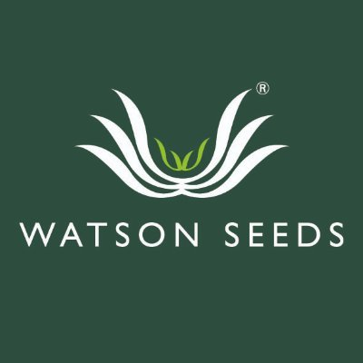

Press release

*for immediate release*

[2 October 2023]

AgriScot Silage Competition Under Starters Orders

Entries have opened for the 22nd annual AgriScot Silage Competition. The competition which has attracted more than 3000 entries since it began, is the longest running silage competition in Scotland. It is a reflection of the high regard the contest is held in, that has kept it going continuously, never missing a year since it began in 2001 - in spite of disasters such as foot and mouth disease and the coronavirus pandemic.
Silage production is vital to farm enterprises across Scotland. Quality is key, particularly at a time when increasing feed and fertiliser costs are putting pressure on farming businesses. Knowing the nutritional value of silage allows for accurate ration planning and regular analysis means variations in quality can be quickly corrected.
The silage competition is divided into four categories: Beef Clamp, Dairy Clamp, Big Bale and a Young Farmer class for those aged 30 and under, which can be submitted from any cut of silage.
Judges will examine the silage analysis report submitted by each applicant, evaluating metabolisable energy, crude protein, and dry matter. Those in the top three of each category will be contacted about having a fresh silage sample collected - which will be judged live on the day of AgriScot.
Organisers of the competition are again anticipating strong entries, with judges whittling submissions down to the top 12 finalists, before revealing category winners at this year’s AgriScot in November.
Farmers have until Monday 25th of October to submit their silage report for the competition.
Andrew Best, Seed Specialist at Sponsors and competition organisers Watson Seeds says: “This year’s silage season has been dominated by weather extremes, with generally good grass growth throughout the season, but tight harvesting windows. First cut silage was of good quality though generated lower yields, and a later period of drought meant that second cut could contain higher fibre grass, reducing silage quality. Post Highland show saw consistently high rainfall and catchy silage making conditions which further reinforces the benefits of analysis to fully understand the value of the silage to the business.”
In the main ring, Judges, Hugh McClymont and RHASS chairman and agronomist, Jim Warnock will judge the final samples, explain their decisions, and entertain the crowd with their forage knowledge and silage analysis feedback.
Jim Warnock said: “I really enjoyed judging the competition last year and having a good craic with silage guru Mr Hugh McClymont, during our commentary. Analysing silage this year is more important than ever, with silage being baled at less than optimum times, reducing ME value. Analysis is a great starting block to understanding what supplements may be needed to perfect feed rations.”
Speaking of winning the Beef Clamp section in 2022, SRUC farm manager, James Marshall says, “We always do our best to make quality forage and, confirmation that we are doing a great job with our silage provides a real sense of pride and achievement. Having the chance to compare with others is inspiring, and to receive feedback from the judges during the competition is invaluable. In farming, there are so many setbacks and hardships which constantly challenge us, so receiving a positive result during the competition is something I can reflect on with pride.”
Winners of each category will be awarded with ten acres of any Watson Seeds Castle Mixture, with second and third place, receiving five and two acres, respectively.
Entries should be emailed to Andrew Best abest@watsonseeds.com by 25th October.
- Ends-

For more information, to arrange an interview or press enquiries, please contact Helen Cork Helen.cork@janecraigie.com / 07751138438

Notes to editors:

The AgriScot Silage Competition is sponsored and facilitated by Watson Seeds.

AgriScot takes place on Wednesday, 22nd November 2023, at the Royal Highland Centre, Ingliston. The awards will be presented at this event.
Contact info@agriscot.co.uk for more information
AgriScot is free to attend, and registration is open at www.agriscot.co.uk
The event is organised by Rural Projects.

Follow AgriScot online:
Facebook - https://www.facebook.com/AgriScot/
Twitter - https://twitter.com/agriscot

