Press release

*for immediate release*

[12 September 2023]

Business Skills Competition offers £1000 cash prize, mentoring and pre-access to UK’s Premier Agricultural Business event.

Business Skills Competition sponsored by NFU Mutual, Managed by SRUC and Supported by SAYFC

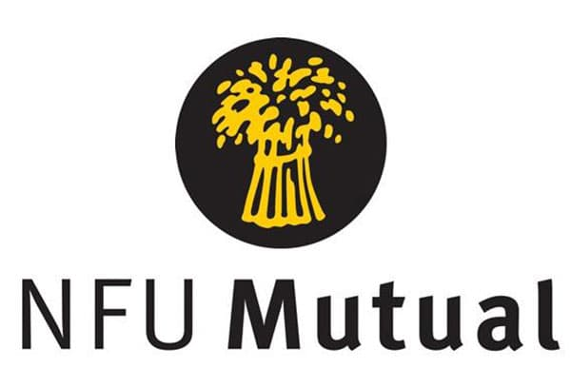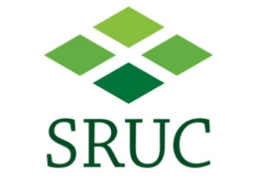

The AgriScot Business Skills, sponsored by NFU Mutual and supported by Scotland’s Rural College (SRUC), looks to support aspiring young professionals by encouraging them to think about the skills required to manage an agricultural business, whilst also connecting them with mentors and networks, to help with their personal and professional development.
The competition, which assesses individuals’ general business skills and awareness of agri-business issues, comes with a £1000 cash prize. In addition, new this year, the two individuals who come runners up will be presented with £250 each, making the competition even more appealing.
Open to individuals between the age of 18 and 25 years, there are three steps:
- Enter by sending in a copy of a CV along with a statement sharing thoughts on “What does a sustainable future look like for Scottish Agriculture?”

- Applications are then shortlisted, with successful candidates invited to one of the regional heats, located across Scotland, where they will explore a farm business, and provide their assessment to a panel of judges.

- The winner of each regional heat is invited to AgriScot (22nd November 2023) to participate in the final, where they will review a new product innovation.

Commenting on the competition, 2022 winner Jack Young is keen to reassure potential applicants that the process is not as daunting as it may seem at first.
“The regional heat was really interesting. We went round individually with a couple of judges, and mentors. They asked us questions picking up on our knowledge of farming, with the aim of understanding how much we knew about the industry. This was all on-farm, and was so easily done, there was no pressure at all.
“£1,000 is a tremendous prize. I was dreaming about it to start with, that you could actually win these kind of things, and here I am. But it wasn’t just the money I came away with, I developed further skills in time management and strategy, which is helping me with our home farm business.”
Heather Kerr from SRUC, AgriScot Business Skills Coordinator, feels this competition is continuing to evolve to the benefit of the industry,
“The topic this year provides flexibility and scope for applicants to really look at what sustainability means for Scottish agriculture. Whether it is sustainability in terms of our landscape, people, environment, cropping and/or livestock, there is no response that is off limits.
“We are looking for someone who is enthusiastic about the agriculture industry and looking to develop their business skills, while talking advantage of the networking opportunities that are on offer from this competition.”
Previous winners have gone on to develop their own businesses, take on key leadership roles within the sector, and this year will see two of them join the judging panel for the AgriScot Product Innovation award, celebrating new innovation.
Commenting on why NFU Mutual continue to sponsor the competition, Martin Malone, NFU Mutual Regional Manager of NI and Scotland) said,
“Agriculture is continuing to adapt to the needs of consumers, political pressures, regulations and accreditation schemes, to name but a few, but what doesn’t change is the skills required by our most precious asset, our people.
“The AgriScot Business Skills Competition brings forward young people who inspire and challenge the status-quo, and investing in their skills development is vital for our sector.”
To find out more about the competition, visit www.agriscot.co.uk or email Heather via heather.kerr@sruc.ac.uk. Applications close on Friday 6th October 2023.
- Ends-

For more information, to arrange an interview or press enquiries, please contact Rebecca Dawes via rebecca@janecraigie.com or 07792 467730

Notes to editors:

The AgriScot Business Skills Competition is sponsored by NFU Mutual, managed by SRUC and supported SAYFC.

AgriScot takes place on Wednesday, 22nd November 2023, at the Royal Highland Centre, Ingliston. The awards will be presented at this event.

AgriScot is free to attend, and registration is open at www.agriscot.co.uk
The event is organised by Rural Projects.

Follow AgriScot online:
Facebook - https://www.facebook.com/AgriScot/
Twitter - https://twitter.com/agriscot
LinkedIn -

