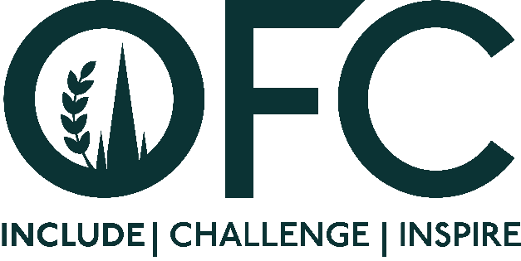
Press Release
[8 August 2023]

Oxford Farming Conference calls for new Directors to help shape the future of the charity

The Oxford Farming Conference (OFC), the UK’s leading agricultural, business and food event, is calling for three new individuals to help shape the future of the organisation.
OFC is run by a group of voluntary Directors who identify the theme, speakers, sessions and overall programme, ensuring the conference continues to deliver on its charitable objectives to include, challenge and inspire the industry.
In addition to the conference, which takes places annually in January, the Directors support a range of outreach programmes including Scholars, which supports those at the start of their career, Inspire, a network to empower and develop the skills of future leaders, and OFC bursaries, for those involved in agriculture who may face social or economic barriers, enabling them to attend the conference for free.
The new appointments will serve a three-year term starting from January 2024, and will be expected to attend the conference themed “The Power of Diversity”, taking place from 3 to 5 January 2024.
Following a skills audit, the Council would be pleased to receive applications from those with scientific and research knowledge, and farmers from across all sectors. However OFC 2024 Chairman, Will Evans, is keen to stress the board is inclusive to all, and applications from anyone with a passion to be at the forefront of the agricultural industry, is encouraged to apply.
“Agriculture is continuing to face unprecented change, but where there are great challenges there are also huge opportunities” said Will
“OFC provides a unique opportunity for the industry to discuss, debate and develop ideas and solutions so we can collaborate to be resilient for the future. This starts with ensuring our board of Directors has a wide breadth of skills and experience, and is representative of many different areas within agriculture.”
The current board includes backgrounds within dairy, livestock, arable, horticulture, regenerative agriculture, environmental support, policy, veterinary, marketing, PR, finance, mental health and wellbeing and international leadership.
“Together we aim to develop a programme of speakers and sessions that responds to both industry and consumer demands, ensuring that hundreds of delegates receive valuable insights to help them shape their businesses, and more widely, the industry.” added Will.
The OFC Directors are supported by a range of contractors on a part-time basis including event logistics, marketing and PR, partnerships and sponsorship, financial administration and general secretariat.
The roles are wholly voluntary with expenses paid, including full conference attendance. Individuals are expected to have attended at least one event, ether in-person or online.
To find out more and how to apply, visit www.ofc.org.uk

ENDS
Issued by Jane Craigie Marketing. For further details or interviews, please contact marketing@ofc.org.uk or Rebecca on 07792 467730

Notes to Editors:
- For more information on the Oxford Farming Conference (OFC):
Website: www.ofc.org.uk
Twitter: @oxfordfarming
LinkedIn: OxfordFarmingConference
YouTube: OxfordFarmingConference
- The Council is made up of 10 voluntary directors. The OFC 2024 Chair is Will Evans
- OFC is held annually in January over three days and includes a vibrant programme of speakers, panel sessions, politics sessions and easy networking.
- The 78th conference will take place from the 3 to 5 January 2024 in Oxford and online.
- OFC has established a reputation for strong debate and exceptional speakers.
- OFC is a charity that invests in the agricultural education and knowledge-sharing. It attracts over 650 delegates every year, including many people from the wider food chain, retail, NGOs, scientific organisations, media, policy-making bodies and governments from around the world.
- With HRH Princess Royal as its patron, OFC is a charity with a remit to educate and transfer knowledge in the agricultural sector. As part of its charitable undertakings, the OFC sponsors young people to attend the conference, to travel overseas and it seeks to develop emerging leaders.

