20th July 2023
Mentoring matters to Ringlink’s Pre-apprenticeship programme
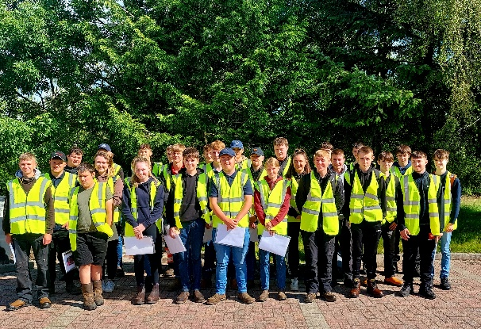
Ringlink’s pre-apprenticeship for 16–21-year-olds has been remarkably successful at attracting new recruits, with almost half of the trainees having no previous agricultural background.
The Land-based Pre-apprenticeship is a vocational pathway for school leavers or new entrants, providing a qualification at SCQF level 4, certificated training tickets and 6 months full-time employment. This work-based model suits the industry well, as it includes the essential upfront Health & Safety awareness and provides the fundamental skills, and competency for a relatively inexperienced person to get a ‘foot on the ladder’.
Gail Robertson, Group Operations Manager says: “This year, a record 29 new trainees have joined the pre-apprenticeship. It is a remarkable success story for our industry, particularly given the increasing difficulties with recruiting staff for farms and rural businesses”
“In the past 10 years, 189 pre-apprentices have passed through the programme, and 80% are still either working on the farm they trained on or working elsewhere within the industry. The pre-apprenticeship is undoubtedly providing a valuable source of new talent for the land-based sector.”
There is a catch, however. Of the 29 new recruits, 4 are still waiting for a mentor who is willing to develop their skills and Ringlink are appealing for businesses from the areas of Arbroath, Forfar, Brechin and Ellon who could offer 6-months employment to get in contact. You don’t even have to be a Ringlink member to be a mentor.
James Porter, Chairman of Ringlink says: “I know from personal experience how rewarding it is, but I am also aware that not every business can either afford the time or the money to take on an extra employee If you are looking to hire staff however, given the shortage of trained farm workers, it makes a lot of sense to take on a pre-apprentice who is enthusiastic, and hasn’t picked up any bad habits”.
James continues: “Ringlink continues to explore potential routes to financially support mentors with Scottish Government. I am very hopeful that a solution will be found which could lead to a massive expansion in the scheme. In the meantime, if you have a business in the areas previously mentioned, there are some very keen individuals on your doorstep who could bring a fresh and revitalising injection of youthful energy into your business. It is vitally important that we keep bringing young people into the industry and we need more mentor businesses to engage and offer these opportunities”.
Ringlink has sourced funding for the Land-based Pre-apprenticeship from Scottish Government as administered by Skills Development Scotland over the last 5 years, with just one year remaining of assured financial support. Given the success of the programme to-date, they remain optimistic that funding will be forthcoming from Scottish Government to allow the pre-apprenticeship to continue and expand.
Investing in the future workforce is important for Ringlink and as such, earlier this year following a grant award from the Loirston Trust, a new simulator has been installed at the Ringlink training centre in Laurencekirk. The simulator allows users to gain initial introductory training on a variety of industry specific plant and machinery such as Tractor, Forklift, Digger, HGV; offering an interactive, safe and cost-effective means of skills development.
Please contact Gail Robertson, 01561 377790 if you are interested in mentoring.

---Ends---
For further information please contact:
Gail Robertson
Group Operations Manager
Direct Dial: 01561 376022
Email: gail@ringlinkscotland.co.uk

About Ringlink Scotland Ltd
Ringlink Scotland is a rural business co-operative, owned by its 3200 members and managed on behalf of its members to provide a cost-effective platform for efficient member to member trading.
Established in 1988 Ringlink has seen significant growth progressing from a company focusing entirely on agriculture into a business with diverse activities to cater for the full scope of membership sectors which include: agriculture, haulage, construction, forestry, public sector and utility providers.
The company has a turnover exceeding £70 million and the business continues to invest and grow year on year.

