Date: 26 July 2023
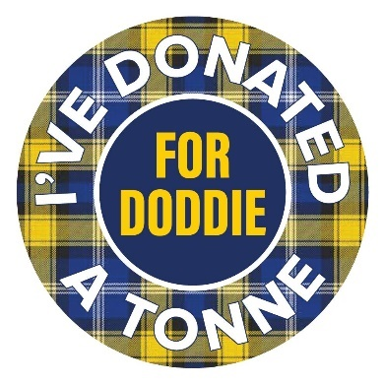
Donate a tonne for Doddie at the Turriff Show

Doddie Weir’s legacy as a campaigner for a better understanding of Motor Neurone Disease (MND) put the disease and fundraising into vital research firmly into the spotlight. Doddie founded the My Name’5 Doddie Foundation charity – the five coming for the number of his Scotland rugby shirt – after he was diagnosed with the disease in 2016, aged 46.

Local architect, Annie Kenyon, recently lost her Mum to the disease in 2021, which fuelled her to raise money for the charity, because she knows, firsthand, how important it is to find a cure.

“The idea to Donate a tonne for Doddie came up when I was sharing a glass or two of wine with Graeme Mackie, we thought it would be lovely for Scottish farmers and businesses involved in farming and rural places to donate the equivalent of a tonne of barley, tatties, carrots, hardcore or anything else, to the Foundation,” Annie says.

“Donations we’ve had so far have been really touching and include a tonne of tatties from Graeme and Julie Mackie, a tonne of love from the Stephen’s at Netherhird and a tonne of dog food equivalent from Harbro. The amusing donations are a tonne of feathers from the McLean family, a tonne of trotters from Christo and Lorraine Shepherd and a tonne of wild oats from Henry Duncan!”

It doesn’t stop there. Annie was approached by Kenny Logan to take part in his World Cup Challenge, so Duncan Barton, Annie’s partner will join Kenny’s team of 20 people cycling from Murrayfield to Paris, with the match ball from the Scotland v Ireland game, in October of this year.

Annie adds: “in parallel with the Donate at tonne, we have committed to raise £15,000 towards Kenny’s target of £555,000 and I am designated fundraising manager! So, I’m doing a few events, golf days, a hoolie, so keep your eyes open for these.

“We are asking people to join us on our stand at the Turriff Show to come and say hello and to donate what they can, and encouraging people thereafter to consider what they can do to help.”

Approximately 1,100 people are diagnosed with Motor Neurone Disease annually in the UK and up to 5,000 UK adults are affected at any one time. Symptoms include spontaneous twitching, fatigue, weight loss, muscle cramps and difficulty in speech and swallowing.

