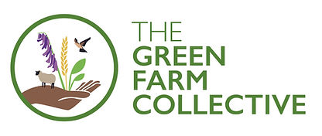
PRESS RELEASE
2 June 2023
New regen food label and £10k prize announced at regen ag conference
More than 220 people, from the Isle of Wight to Yorkshire, joined the Green Farm Collective (GFC), at its second Open Day in Boningale, Shropshire, to learn how farmers can alter practices and return nutrients to the soil, our food and ourselves.
The GFC is a group of farmers who met through the, ‘Soil Farmer of the Year’ awards. Each of the six members believe in the reduced use of pesticides and increased carbon capture through improvements in biodiversity, water, air and soil, and are actively improving their own farms, welcoming people on farm to see the changes being made.
​
Opening the event, GFC founder and host, Michael Kavanagh, explained the four GFC pillars: knowledge exchange for members, , new this year, the sale of regenerative produce, using the GFC’s audited, premium, regenerative label.

Tim Parton, Staffordshire farmer and GFC founder, also announced a £10,000 prize competition to be run by the GFC, ‘The Green Innovation Award’. To enter, competitors will need to demonstrate how they would implement an innovation on farm, which improves the farming system, has a marked impact on the sustainability of the farm, or sees significant biodiversity improvements.

​As well as a broad programme of talks operated across two barns throughout the day, the ‘Livestock Collective’ and the ‘Collective Barn’, Michael shared the work he’s been doing, explaining soil microbes and compost, dung beetles, hedgerow benefits, agroforestry, livestock health and grazing, carbon trading and importantly, human health.

“It’s encouraging to understand that what we are doing as farmers, is linking to human health. Collaboration and sharing ideas are crucial to moving agriculture into this new era. It’s thought-provoking to hear multiple speakers talk about the importance of what works for your farming system, and your family, and addressing the mental health aspects of farming, a conversation that needs raising more within farming communities.”

Speaker and GFC honorary member, Patrick Holford, spent 40 years studying human health and believes that we can increase the nutrient value of food, by better managing the soils it’s grown in, therefore reducing the amount of food we need to eat to obtain nutrition for overall health.

Patrick endorses the GFC regenerative farming methods, as he explained important synergies, through his presentation, ‘Soil-food-gut-brain superhighway:

“Research shows that health issues can be solved with correct nutrition. Healthy soil improves food nutrient density, which improves our health and the quality of our lives. My focus now, is on agricultural soils.”

RhyzoPhyllia founder, Eddie Bailey, explained his Mychorrhizal research, illustrating the soil food web and how it supports plants to thrive in healthy soil. Eddie explained how composting is essential in aids crop growth crops and weed suppression:

“I am passionate about regenerative agriculture; putting life back into our soil, creates nutrient dense plants, which creates healthy people, sequesters carbon and improves the climate; I just don’t think there is anything more important than regenerative agriculture.”

Tim made the change to regenerative practices when he learned the link between his diet and health, realising how our daily lives can be transformed through good nutrition. He reassured visitors that there is support in the transition to regenerative agriculture, saying,

“Regen throws challenges, we have to be brave and create solutions; together we can do this, through sharing our learning and knowledge; change isn’t easy, but the right agronomist and people around you, will help.”

He believes this will be the biological century for farming, leaving the chemical century behind, growing nutrient dense food and healing the planet. On his farm, he sap tests plants regularly, with biological foliar applications at night as needed, to assist plant thriving ability, aware that between the hours of 3am and 8am, plants do their biology, ready to photosynthesise during the day.

With sustainability high on the public and farming agendas, the GFC Open Day gave visitors greater tools, knowledge and connections to help achieve this. Robyn Munt from the Isle of Wight, who extensively farms 2000 ewes on cover crops, said:

“After visiting last year, I was excited to return and hear about the practical elements of managing herbal leys and livestock, see the innovative tech and seed mixes - there is such a range of knowledge to take home and tell friends. I found it fascinating to be talking about what we produce, and how that can benefit human health.”

The GFC thanks exhibitors, speakers, sponsors and visitors for making the day a great success. Closing the event, the Farming Community Network (FCN) handed out raffle prizes donated by sponsors, Trinity, GFC, Field Mouse, Interagro, Crop Intel and Groundswell, raising awareness of the brilliant work the FCN does, supporting farmers with mental health issues ranging from relationship breakdowns to challenging farming times.
For more information from the GFC please see here.

Further visitor comments from those attending the day:

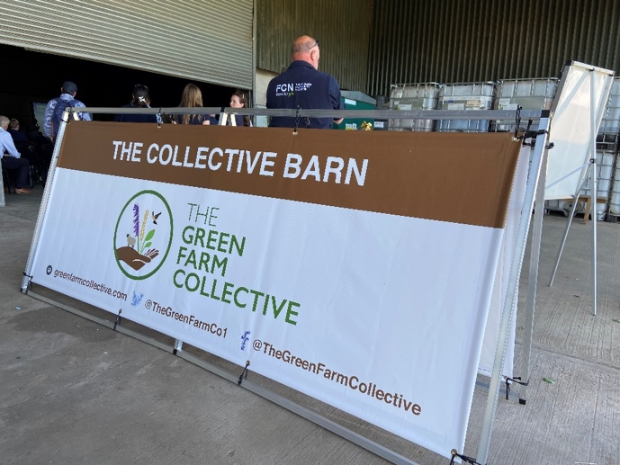

Visitor Shropshire farmer, Tony Madeley, was fascinated to hear how diet can alter our risk of Alzheimer’s and Dementia:

“My son and I want to move away from our input-based system, losing our minds is a frightening prospect and now I know we can make changes to reduce the risks. Today I have understood more and met people that can help us to make this happen.”

Rob Beaumont is a farmer and agronomist for Edaphos, “I came to learn about biodiversity net-gain, improvements in soil health and how we can best move forward with our businesses.”

Other visitors have been farming with conservation in mind for years, including Cornwall farmer, Martin Howard produces 100% grass fed beef and is interested in finding out how to improve human health through food, saying,

“Patrick Holford was fascinating, food is our medicine and I am learning here, how to push the limits of my low input farming system, how to go no-till, implement rotational grazing, use biology; taking the next steps to farm better with knowledge gained from those here today.”

