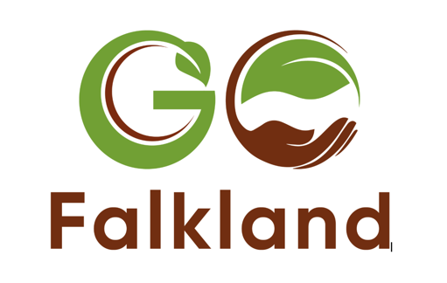
PRESS RELEASE
26.5.23

A groundswell sparks new regenerative farming festival for Scotland

A new regenerative farming event will be held in Scotland this summer. GO Falkland, hosted on the Falkland Estate in Fife, will bring together speakers from across agriculture, agroforestry, soil biology and food provision, to create a one-day discussion forum for farming businesses and others interested in a profitable, sustainable approach to food production and soil health.

The vibrant programme has been designed by a collaborative network of Scottish farmers, foresters and educators alongside the Falkland Estate team, attracting speakers from across the globe, and will follow the same ethos as the renowned Groundswell Festival, hosted by the Cherry family in Hertfordshire.

With sessions relevant to conventional, organic, livestock and arable farmers at any stage of the regenerative journey, GO Falkland will be held on Saturday 1st July.

Ninian Stuart, whose family owns the 1900-hectare Falkland Estate, a mix of arable and rough grazing, has a longstanding appreciation of a regenerative approach to farming and land management. As well as being open to the public, the estate has hosted a number of events, including the highly successful Big Tent Festival. He said:

“There’s a huge swell in interest in this approach to farming and we know there’s a growing appetite in Scotland to do more. We look forward to welcoming farmers, smallholders and growers, and others with a keen interest, whatever their perspective, views or knowledge, including those looking to take the first steps. We’re really excited to make this happen in the heart of Scotland and with such a prestigious mix of speakers. It will be a fun, informative day with plenty of opportunities to trigger different thinking and reimagine the future of food and farming.”

Across the three different tents, speakers include soil health expert, Joel Williams, Anne Biklé, author of What Your Food Ate and Helen Browning OBE, farmer and CEO of the Soil Association. Other key sessions include soil science and designing farming systems; growing trees in farming systems; leveraging natural capital, and ag-tech; enterprise stacking; and enhancing local food systems.

Another highlight includes panel session with farmers who have experimented with regenerative approaches in Scotland, including David Aglen, farm manager at Balbirnie Estate in Fife, Alex Brewster at Rotmell near Dunkeld and Aberdeenshire-based Nikki Yoxall who started the mob grazing enterprise, Grampian Graziers.

GO Falkland is a pilot fringe event for the well-known regenerative farming event, Groundswell Festival, now in its eighth year, to extend the conversation into different regions around the country and their specific farming landscapes. Geared to Scotland’s climate and landscapes, it is independently organised by the committee for GO (Groundswell Outreach) Falkland but follows a similar ethos to Groundswell Festival.

Groundswell Festival co-founder, Joanna Cherry, said the growing interest in regenerative agriculture comes not only from farmers, but also from policy makers attracted by the ‘public benefits’ of systems such as carbon sequestration and flood and drought prevention, and discerning foodies. Of the event in Scotland this summer, she said:

“It’s fantastic to see what we started gain such momentum and for the conversation to now extend like this to a different part of the country in the capable hands of Ninian and his team. We’re excited to sense a real movement underway as we all work together in this new era of food production to sustain our soils and our businesses.”

The original Groundswell event in Hertfordshire now welcomes over 5,500 visitors and will take place a few days before GO Falkland. The first GO Falkland event has a strictly limited number of tickets for 500 visitors.

For the full programme and to book tickets for GO Falkland see: https://falklandestate.co.uk/go-falkland/. Ticket numbers are strictly limited so please book early to avoid disappointment.
Editor’s Notes:

For more details on Go Falkland see www.falklandestate.co.uk/go-falkland/ and on Falkland Estate, see https://falklandestate.co.uk/about/

