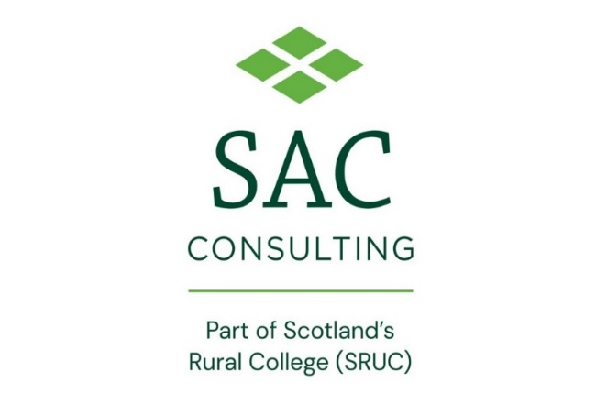
Press Release
For immediate use
15 December 2022

Potato conference seeks to boost growers’ confidence amid global challenges

The ongoing impact of the war in Ukraine and the pressure of reducing carbon footprints will be on the agenda when Scotland’s biggest potato conference returns in the new year.
Organised by Scotland’s Rural College (SRUC), the 24th annual conference of the SAC Association of Potato Producers (SACAPP) aims to boost growers’ confidence amid the current challenges. It hopes to welcome around 150 delegates to gather in person for the first time since 2020 for a day of discussion, workshops, and networking.
The theme of the conference will delve into the question ‘Is growing potatoes sustainable and profitable?’, taking in to account the difficulties facing growers around rising energy costs and increasing pressure to reduce their carbon footprints.
There will be a range of speakers, including an update from Keith Dawson on what is happening in Ukraine and how potatoes are being affected; Mike Neaverson will explore how long we will be able to grow potatoes in the fens; lead agronomist for McCain, Matt Smallwood, will zone in on how far growers can move towards sustainability and Ingo Hein will give an update on breeding the next generation of potato varieties.
Delegates will have plenty of time to network with other growers, take part in workshops on virus control and mitigating costs, as well as hearing valuable advice, ranging from reducing wastage to making storage more efficient. The afternoon will round off with an update from SRUC’s chief economist Steven Thomson, with a presentation on the value of potatoes to the economy.
Lead organiser Dr Philip Burgess said: “Costs of production are enormous and that is the only conversation we are having with growers right now, it always comes back to sustainability of production, both economically and environmentally.
“Are we going to be able to continue to grow potatoes profitably and to meet demand with consumers, as well as provide seed for the rest of the country?
“The potato industry is going through a period of change, in terms of costs of production, pressure to reduce its carbon footprints and, in order for growers to remain at the forefront of the industry, they need keep up to date and this is an excellent opportunity to hear what is going on and to network with people in the industry.”
The conference will take place between 9.30am and 3.30pm on 25 January 2023 at The Apex City Quay Hotel, Dundee. Refreshments and lunch are provided. The event is free to SACAPP members, but tickets are available to purchase for non-SACAPP growers and trade. For more information and to book your tickets, please email, sacapp@sac.co.uk.
ENDS
For more information, please contact Claire Taylor on claire@janecraigie.com or 07726219687.
Notes to Editors:
Scotland’s Rural College (SRUC) was established in 2012 through the merger of the Scottish Agricultural College (SAC) with Barony, Elmwood and Oatridge Colleges. Through these institutions, we can trace our lineage back over 100 years.
Today, SRUC is on a journey to become Scotland’s enterprise university at the heart of our sustainable natural economy. Our mission is to create and mobilise knowledge and talent – partnering locally and globally to benefit Scotland’s natural economy.
To achieve this, we draw upon SRUC’s longstanding strengths in world-class and sector-leading research, learning and teaching, skills and training and consultancy (through SAC Consulting).
As part of SRUC, SAC Consulting provides independent, research-driven, industry-leading expertise, advice, and solutions for agricultural, food, and land-based businesses. With 24 offices and an experienced, expert team, it provides local support, tailored to its customers, nationally.
www.sac.co.uk

