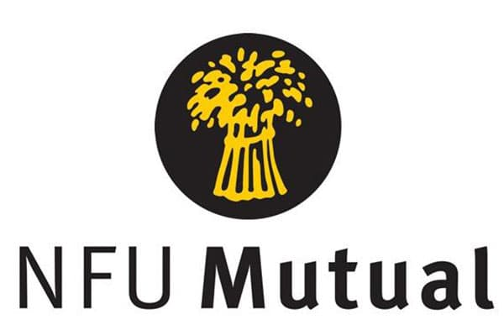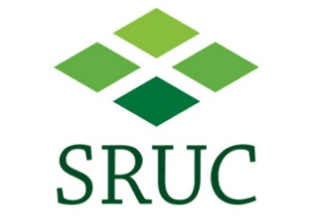

Press release

*for immediate release*

[14 September 2022]

Business Skills Competition offers £1000 cash prize and prepares the next generation of agri-business managers.

The AgriScot Business Skills, sponsored by NFU Mutual and supported by Scotland’s Rural College (SRUC), looks to support aspiring young professionals by providing them with the skills and networks required to mitigate and manage the many challenges facing rural and agricultural businesses.
The competition, which assesses individuals’ general business skills and awareness of agri-business issues, comes with a £1000 cash prize to help them in the future.
With soaring costs, staff recruitment challenges, food security concerns and supply chain demands, to name but a few, this year’s theme is aptly focused on resilience.
Open to individuals between the age of 18 and 25 years, entry includes a copy of a CV along with a statement sharing thoughts on “The importance of Agri-business managers developing more resilient businesses”. Aligning with AgriScot’s new digital approach, applicants can enter by submitting a video or in writing (no more than 400 words).
Heather Kerr from SRUC, AgriScot Business Skills Coordinator, feels this competition helps prepare individuals as they develop their careers.
“Over the last decade agriculture has faced unimaginable change, with plenty more on the horizon. This adds extra pressure to farming businesses which are unable to generate secure plans and predict the resources they will need in the months ahead, let alone years.
“Agri-business managers need to be armed with skills and networks so they can be agile and adapt to the unpredictability, whilst also managing their own personal resilience. This competition gives applicants the opportunity to work through a real-life scenario, and a chance to win some cash to invest in their future.”
Semi-finalists will attend an on-farm event where they will receive a farm tour, hosted by a panel of judges who will discuss aspects of the farm enterprise with the applicant. Those who most impress the judges will go through to the final, which takes place at AgriScot on Wednesday 16th November 2022.
Commenting on why NFU Mutual continue to sponsor the competition, Mark McBrearty, NFU Mutual Regional Manager (Scotland) said,
“The skills required to run an agricultural business are widespread from financial management and trading to human resources, marketing and diversification. Agri-business managers need to be far more versatile than ever before, and this competition allows us to support the next generation of managers as they continue to arm themselves with all the skills they may require.”
To find out more about the competition, visit www.agriscot.co.uk or email Heather via heather.kerr@sruc.ac.uk. Applications close on Friday 7th October 2022.
- Ends-

For more information, to arrange an interview or press enquiries, please contact Rebecca Dawes via rebecca@janecraigie.com or 07792 467730

Notes to editors:

The AgriScot Business Skills Competition is sponsored by NFU Mutual and supported by SRUC.

AgriScot takes place on Wednesday, 16th November 2022, at the Royal Highland Centre, Ingliston. The awards will be presented at this event.
Exhibitor stands for AgriScot 2022 have now sold out, but space for seminars is still available. Contact info@agriscot.co.uk for more information
AgriScot is free to attend, and registration is open at www.agriscot.co.uk
The event is organised by Rural Projects.

AgriScot sponsors include: Aberdeen Angus Cattle Society, ABP, Ayrshire Cattle Services, Arla, Brodies LLP, CIS, Cogent, CowAlert, Datamars, Davidsons Animal Feeds, Farmplan, Harbro, Holstein UK, Kilpatrick & Walker, Krone, McCaskie Farm Supplies, Merlo, McCormick, Moredun, NFUS, NFU Mutual, Norvite, NWF, Power Washer Services, SAC Consulting, Scottish Farmer, Scot Agri, QMS, Semex, Soil Essentials, Spaldings, Thomas Sherriff, Thorntons Law LLP, Watson Seeds, Yara UK

Follow AgriScot online:
Facebook - https://www.facebook.com/AgriScot/
Twitter - https://twitter.com/agriscot

