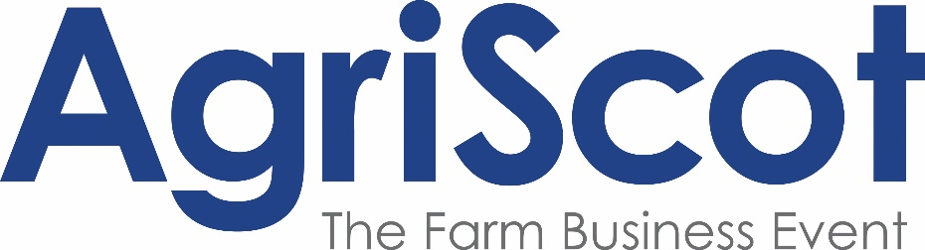

Press release
*for immediate release*
[23 September 2022]

AgriScot show ring set to draw dairy herds, competing for a share of £25,000

As the UK’s leading agricultural business event approaches, AgriScot is set to draw dairy herds from across the UK and Ireland, as they compete to be in with a chance of winning a share of £25,000, the largest prize fund available in the country.
In addition to the traditional Ayrshire, Red and Whites, Holstein and Jersey categories, the dairy cattle show programme will also feature an ‘Any Other Dairy Breeds’ class, welcoming exhibitors of in-milk heifers and cows from the likes of Brown Swiss, British Friesian and Dairy Shorthorn varieties.
Judging of the dairy classes will culminate with the Super Heifer and Super Cow awards, each offering a £1000 prize for eligible cattle.
Responsible for making those decisions is Niels Erik Haahr, this year’s judge. As one of the top Holstein breeders in Denmark and running a herd of 600 cows, Mr Haahr also works with cattle across Europe, investing in high-quality genetics from across the world.
Commenting on what he will be looking for at AgriScot 2022, he said:
“I follow a two-type model when it comes to assessing cows. I’m searching for a well-balanced animal with super feet and legs as well as an outstanding udder. The mammary system is very important for me, and key for any dairy producer looking to get a good result from their herd.
“At my core, I’m a dairyman who enjoys nice cows. It’s a privilege to have been appointed as judge, and I’m really looking forward to seeing some of the UK’s top breeders in action at the event.”
Robert Hunter, Chair of the Scottish Dairy Cattle Association and AgriScot Director added: “I can’t believe how quickly AgriScot has come around again, and the extensive dairy programme is certainly a highlight of the day.
“With 14 classes all coming for the £25,000 prize fund, thanks to our generous sponsors, the ringside atmosphere is sure to be electric.”
For more information on AgriScot and for the full Dairy Cattle Classes schedule, visit www.agriscot.co.uk. Applications close on 28th October 2022.
-Ends-
For more information, to arrange an interview or press enquiries, please contact Rose Moggach via rose@janecraigie.com or 07493 876646

Notes to editors:

AgriScot takes place on Wednesday, 16th November 2022, at the Royal Highland Centre, Ingliston. The awards will be presented at this event.
Exhibitor stands for AgriScot 2022 have now sold out, but space for seminars is still available. Contact info@agriscot.co.uk for more information
AgriScot is free to attend, and registration is open at www.agriscot.co.uk
The event is organised by Rural Projects.

AgriScot Dairy Cattle Classes sponsors include: ABS, Ayrshire Cattle Services, Arla, CIS, Cogent, Datamars, Davidsons Animal Feeds, Farmplan, Fullwoodhead Dairy Supplies, Genus, Holstein UK, Kilpatrick & Walker, Krone, McCaskie Farm Supplies, Moredun, Norvite, NWF, Power Washer Services, Semex, Thomas Sherriff, Yara UK

AgriScot sponsors include: Aberdeen Angus Cattle Society, ABP, Ayrshire Cattle Services, Arla, Brodies LLP, CIS, Cogent, CowAlert, Datamars, Davidsons Animal Feeds, Farmplan, Harbro, Holstein UK, Kilpatrick & Walker, Krone, McCaskie Farm Supplies, Merlo, McCormick, Moredun, NFUS, NFU Mutual, Norvite, NWF, Power Washer Services, SAC Consulting, Scottish Farmer, Scot Agri, QMS, Semex, Soil Essentials, Spaldings, Thomas Sherriff, Thorntons Law LLP, Watson Seeds, Yara UK

Follow AgriScot online:
Facebook - https://www.facebook.com/AgriScot/
Twitter - https://twitter.com/agriscot

