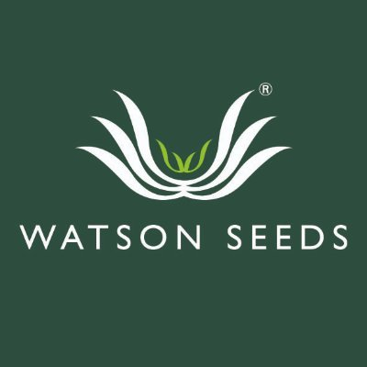

Press release

*for immediate release*

[12 September 2022]

Silage competition highlights importance of good forage analysis

AgriScot’s hotly contested silage competition is now open, with organisers anticipating a bumper year for entries, as home-produced forage becomes ever more critical to farming businesses in the current climate.
With most farmers facing tighter profit margins against the backdrop of spiralling energy, feed, fuel and fertiliser prices, producing high quality forage will prove key to keeping feed costs down.
Farmers have until Monday the 17th of October to submit their silage analysis to sponsors and organisers Watson Seeds, and have four categories to choose from, including: Beef and Dairy Clamps; Big Bale and a Young Farmer class for those under 26, which can be submitted from any cut of silage.
Entries will then be whittled down to three finalists within each category, with the winners being announced during AgriScot, following a live forage analysis.
Organiser Andrew Best encouraged farmers to submit their samples, pressing the importance of forage analysis, as feed costs continue to rise.
“Long dry spells this summer will have affected certain regions more than others and will no doubt have had an impact on silage quality and quantity, and with volatile weather patterns likely to continue in the years to come, the need for conducting silage analysis grows increasingly important.
“For every farm across Scotland, it is important to have a baseline with your silage, so you know how you are best to ration it. Home-produced forage is still the cheapest feed you can have on any farm and with production costs spiralling, will prove critical to keeping costs down.”
Last year’s winner of the Dairy Clamp section, Daniel Ritch, from Brettobreck farm in Orkney, shared his experience of the competition:
“We were over the moon to win in 2021 and it was quite an achievement for this far north in Orkney, it definitely helped put us on the map. Entering the competition was such a simple process, we just had to email over our analysis, and we have been delighted with the 10 acres of grass seed we won as a prize. We used variety Duart, for a trial this year on a 12-acre park and put forage peas in it, which have been under sown with grass seed and it came out as a really good crop, 192 bales which will be this year’s winter protein.”
The Silage competition is a firm favourite with AgriScot delegates, gathering to hear expert commentary from the judging panel. Hugh McClymont will be entertaining crowds as ever this year, with his specialist commentary and nose for quality forage and will be joined for the first time by RHASS chairman and agronomist, Jim Warnock.
Commenting, Mr Warnock said: “There has never been a more crucial time to secure high quality forage as it is the cheapest feed you will secure for your animals during the winter months. So much good grassland is lost by high infestation by aggressive weeds, as farmers tend to prioritise other land first. More time and effort must go towards the renewal of grass swards, but fundamental to that is soil analysis. By understanding and improving your soil PH, you will get a much better sward, and this will translate into better value on fertiliser spend and higher quality silage.”
There are excellent prizes up for grabs, with the winner of each category being awarded 10 acres of any Watson Seeds Castle Mixture, with second and third place, receiving five and two acres, respectively.
All entries should be sent to Andrew Best no later than the 17th of October by email to abest@watsonseeds.com

- Ends-

For more information, to arrange an interview or press enquiries, please contact Claire Taylor via claire@janecraigie.com or 07726 219687

Notes to editors:

The AgriScot Silage Competition is sponsored and facilitated by Watson Seeds.

AgriScot takes place on Wednesday, 16th November 2022, at the Royal Highland Centre, Ingliston. The awards will be presented at this event.
Exhibitor stands for AgriScot 2022 have now sold out, but space for seminars is still available. Contact info@agriscot.co.uk for more information
AgriScot is free to attend, and registration is open at www.agriscot.co.uk
The event is organised by Rural Projects.

AgriScot sponsors include: Aberdeen Angus Cattle Society, ABP, Ayrshire Cattle Services, Arla, Brodies LLP, CIS, Cogent, CowAlert, Datamars, Davidsons Animal Feeds, Farmplan, Harbro, Holstein UK, Kilpatrick & Walker, Krone, McCaskie Farm Supplies, Merlo, McCormick, Moredun, NFUS, NFU Mutual, Norvite, NWF, Power Washer Services, SAC Consulting, Scottish Farmer, Scot Agri, QMS, Semex, Soil Essentials, Spaldings, Thomas Sherriff, Thorntons Law LLP, Watson Seeds, Yara UK

Follow AgriScot online:
Facebook - https://www.facebook.com/AgriScot/
Twitter - https://twitter.com/agriscot

