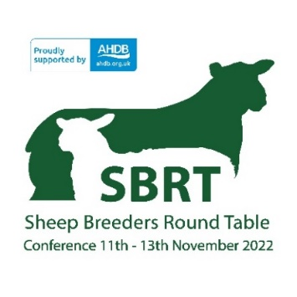
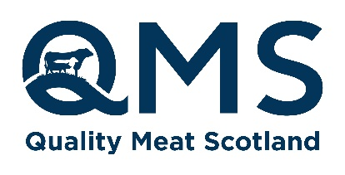
News Release
1 August 2022
For immediate use

Sheep Breeders Round Table – Premier conference for UK sheep farmers
Tickets on sale now
The Sheep Breeders Round Table is back as a face-to-face event to be held from Friday 11 - Sunday 13 November 2022 at the Radisson Blu Hotel at East Midlands Airport.
This year’s theme will be ‘UK sheep genetics delivering for the nation’ with sessions including the following topics:
- Systems and tools to drive the development of genetics for UK sheep farms
- The characteristics needed in sheep for the future
- Satisfying the consumer – factors influencing sheep meat quality
- Opportunities for the sheep sector – market place, genetics and support schemes
- Increasing the impact of existing breeding schemes
- Responsibility of breeding for better health
- What will the sheep industry look like in 10 years?

On the Saturday afternoon the conference will debate the motion ‘The use of advanced breeding techniques has positively benefited the British sheep industry over the past 35 years’.
The event is a platform for showcasing how we can become more resilient and be amongst the best sheep producers in the world. If you have an interest in sheep production, this event attracts a large audience of progressive farmers and breeders, combined with academic researchers and specialist vets sharing their thoughts and ideas.
Bruce McConachie, head of industry development at QMS says, “I would encourage anyone with an interest in sheep production to come along to this convention that is truly at the fore of industry advancement.
“At what is such a pivotal time for the sector, having the opportunity to feed off and share ideas with industry experts and experienced breeders is so important, especially when it comes to thinking about your own business and creating long-term success.”
SBRT welcome sponsorship for the Friday session from CIEL, the Centre for Innovation Excellence in Livestock.
Tickets and accommodation are on sale now. Visit https://events.ahdb.org.uk/ to secure your spot.
ENDS
Notes to editors:
SBRT is an industry initiative, with collaboration from all levy boards AHDB Beef & Lamb, Hybu Cig Cymru (HCC), Quality Meat Scotland (QMS) and AgriSearch combined with support from the National Sheep Association (NSA).
QMS is the public body responsible for promoting the PGI labelled Scotch Beef and Scotch Lamb brands in the UK and abroad and also promoting Scottish pork products under the Specially Selected Pork logo.
Please note that the use of the word Scotch in the Scotch Beef PGI and Scotch Lamb PGI brands is correct and should not be substituted for an alternative such as Scots or Scottish. The history of the use of the word Scotch in this way, traces back to the 18th century.
QMS also helps the Scottish red meat sector improve its sustainability, efficiency and profitability and maximise its contribution to Scotland's economy.
The quality assurance schemes run by QMS cover more than 90% of livestock farmed for red meat in Scotland. They offer consumers in the UK and overseas the legal guarantee that the meat they buy has come from animals that have spent their whole lives being raised to some of the world’s strictest welfare standards.
Scotland’s beef, lamb and pork producers make an important contribution to the country’s economic, social and environmental sustainability, contributing over £2 billion to the annual GDP of Scotland and supporting around 50,000 jobs (many in fragile rural areas) in the farming, agricultural supply and processing sectors.
For more information visit www.qmscotland.co.uk or follow QMS on Facebook or Twitter.

