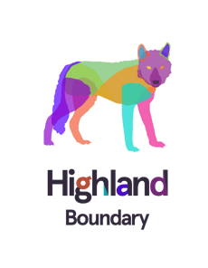
Press Release
20.5.2022

Highland Boundary Spirits Go Wild at The Chelsea Flower Show

Next generation, ethical Scottish distillers Highland Boundary (www.highlandboundary.com) showcases its talent for flavour innovation by supporting two gardens at the Chelsea Flower Show 2022.
Partnering with Jane Porter (https://www.instagram.com/plantyjane/) designer of the “Still Garden” at the 2022 Chelsea Flower Show, Highland Boundary Distillery introduces their bespoke designed “Still Garden Glee” cocktail which celebrates the tradition of distilling and the wild flavours of Scotland. Garden designer Jane said
“The inspiration for the garden came from the long tradition of distilling in Scotland and the native plants found in the Scottish landscape.”
Family-owned Highland Boundary distillery embodies the next generation Scottish distillers focussed on sustainably harvested local ingredients and flavour innovation. Distiller and founder, Dr Marian Bruce uses her scientific background to research and create Scottish spirits that showcase the flavours of wild Scotland. Highland Boundary’s remarkable multi-award-winning spirits aim to re-connect people with the native, natural flavours of Scotland and their cultural traditions. Renowned as wild flavour innovators, Highland Boundary research ancient recipes and ethnobotanical uses of Scotland’s flora. Then they use innovative distilling and extraction techniques to capture nature’s wild flavours from which they create contemporary spirits and exquisite wild cocktails. Marian explains that
“The Still Garden Glee cocktail celebrates the current distilling renaissance in Scotland and showcases the flavours from the wild plants in the landscape that inspired Jane’s design. We’ve loved collaborating with Jane on her garden and are delighted to help her celebrate here at Chelsea.”
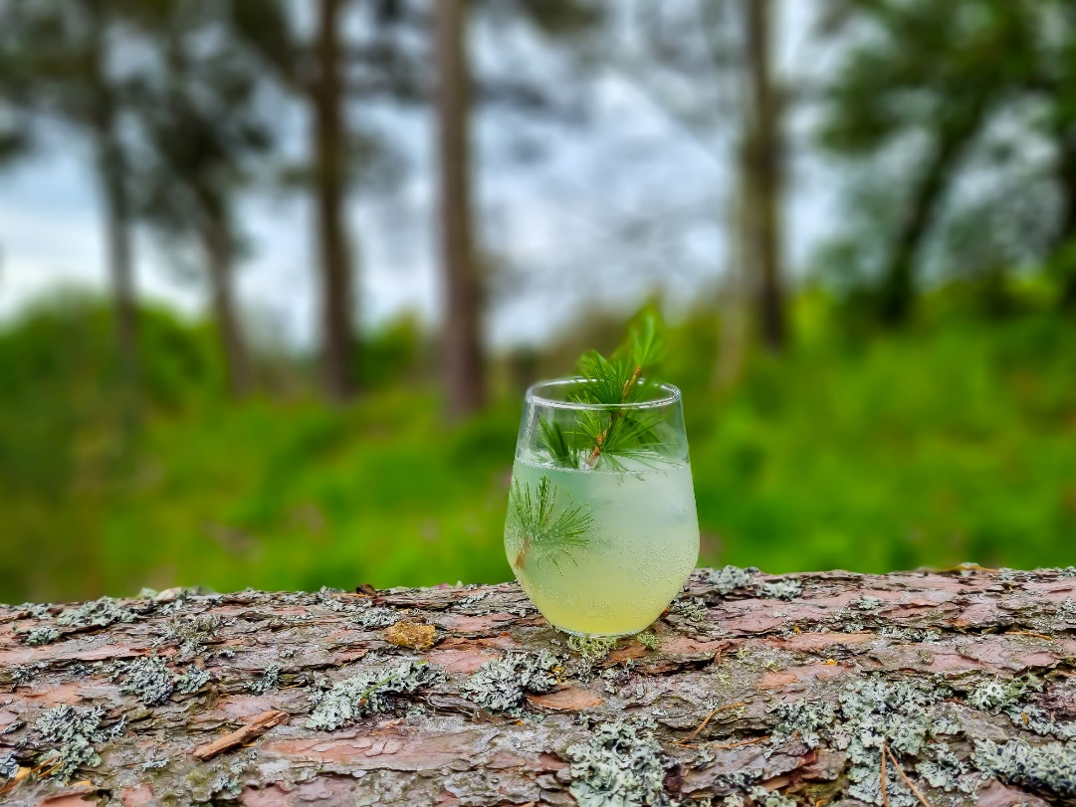

Cocktail: Still Garden Glee
- Larch & Honeysuckle Wild Scottish Spirit
- Scot’s Pine syrup
- Rowan tincture
- Garnished with larch needles

As biologists Marian and Simon from Highland Boundary understand the resilience that biodiversity brings to our countryside and are working to reverse the current crisis in our degraded ecosystems. Highland Boundary are the only distillery and founding members of the Scottish Rewilding Alliance.
As close partners with Rewilding Britain https://www.rewildingbritain.org.uk/ they are also working to celebrate the “Rewilding Britain Landscape” garden, designed by Lulu Urquhart and Adam Hunt. The Rewilding garden includes a whole ecosystem of native plant species, trees and shrubs and a carefully crafted beaver dam (without the beaver!). Marian expands:
“Beavers are keystone species in the British landscape and the recent re-introduction of this species across the UK ensures that they are now able to do their work as ecosystem engineers, creating wetland habitats that benefit a multitude of insect, amphibian and fish species as well as wetland plants.”
The “Wild Landscape” cocktail features one of the beavers favourite trees, the birch, along with hawthorn and honeysuckle syrups and is garnished with sweet woodruff, an aromatic woodland flower - species that are all present in the garden.
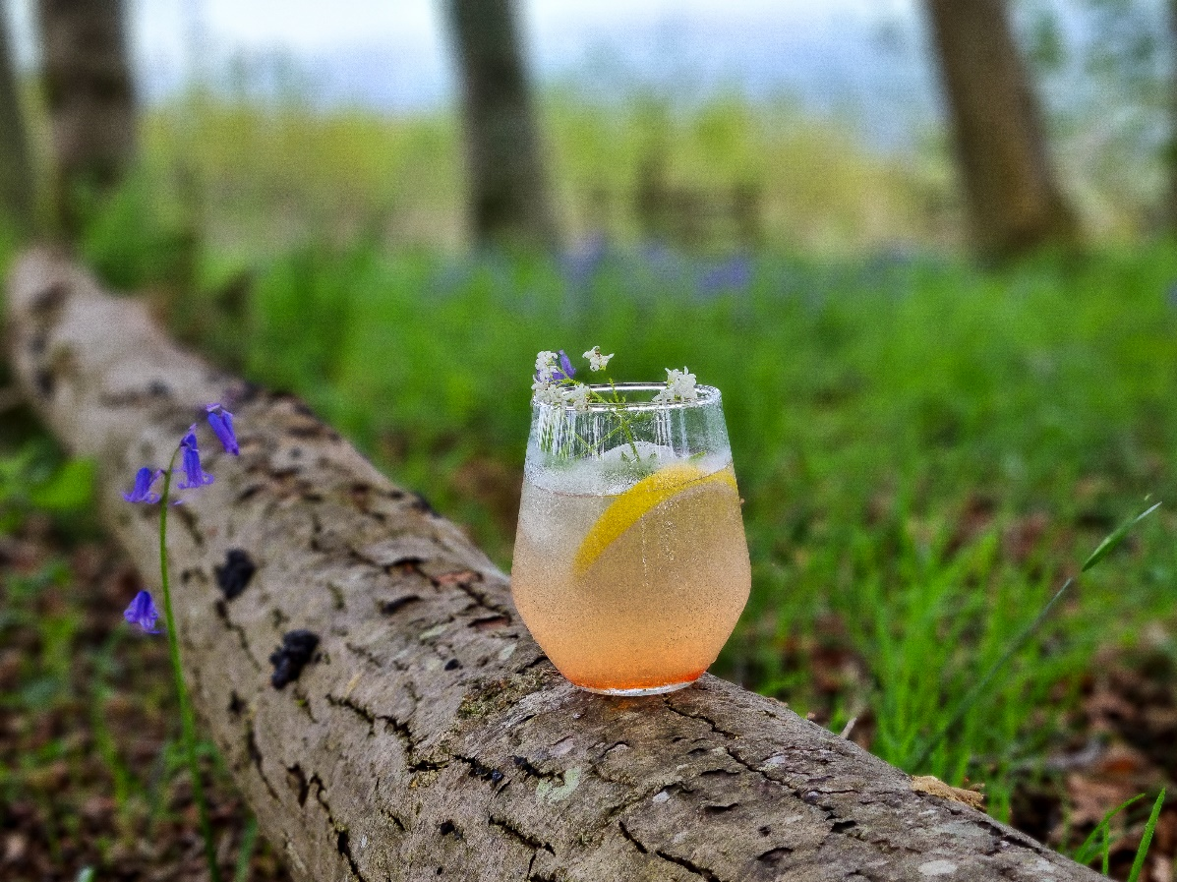
Cocktail: Wild Landscape
- Birch & Elderflower Wild Scottish Spirit
- Hawthorn Flower and Berry syrup
- Honeysuckle syrup
- Garnished with sweet woodruff

For press enquiries contact:
Dr Marian Bruce
Founder, Director and Distiller at Highland Boundary Ltd.
marian@highlandboundary.com
07917 430200

Information for Editors
Link to Images
https://www.dropbox.com/scl/fo/84w8k04arrm53w19pi0qh/h?dl=0&rlkey=wedn512qk4cor8x871pqyqag7

About Highland Boundary
Highland Boundary on-farm distillery was founded in January 2016. Highland Boundary design and distill botanical spirits and liqueurs using only hand-picked Scottish plants. Their multi-award winning spirits and liqueurs capture the wild flavours of Scotland.
Marian is the designer and distiller and she is helped by a small and passionate team. They care about the environment; harvest with great care and sustainably; only use recyclable materials in their bottling and packaging; and have solar-PV and biomass energy sources for their business.
Their name comes from their location. The distillery sits on the geological feature called the Highland Boundary Fault. This is the dividing line between the highlands and lowlands of Scotland and their spirits are made using botanicals collected in the forests of the Highlands and grain spirit grown in lowlands.
Highland Boundary | Wild & Botanical Scottish Spirits

More on Rewilding at Highland Boundary and Kirklandbank Farm
Over the past 12 years at Kirklandbank Farm, Highland Boundary have created a wildlife pond which is thriving with aquatic and wetland plants and associated insects and animals including damsel-flies, dragonflies, newts and frogs. They have planted several wildflower meadow areas with local seeds sourced from Scotia Seeds in Angus to stay in keeping with and support native species. They have planted new hedgerow areas that now offer a habitat for common species such as blackthorn trees from which they will harvest sloe berries in the years to come. These hedgerows also provide a safe and welcoming place for local wildlife to call home all year round.
In this time tree numbers have been increased 5-fold and the number of different wild plant species has been trebled from 54 to 162, vastly increasing the biodiversity on the farm.
The apothecary garden at Highland Boundary has seen great progress over recent years. Throughout history, apothecary gardens served as a place to grow medicinal herbs and plants for traditional healing remedies. The team have been planting a range of apothecary plants and native Scottish species, some well-known such as borage and sweet violet and some that are rare in the wild. They are being used in ongoing research and development of plant-based flavours and products.
Highland Boundary are founding members of the Scottish Rewilding Alliance. The Scottish Rewilding Alliance is a collaboration between like-minded organisations who share a mission to enable rewilding at a scale new to Scotland.
Their approach embraces working in partnership with landowners, communities, interest groups and government to achieve a shared agenda that shapes the landscape. The goal is a flourishing ecosystem, supporting self-sustaining nature-based economies which secure a future for local communities.

