PRESS RELEASE
25.3.22

No-fuss fresh mash direct from the farm gate on Scotland’s coastal route

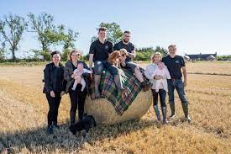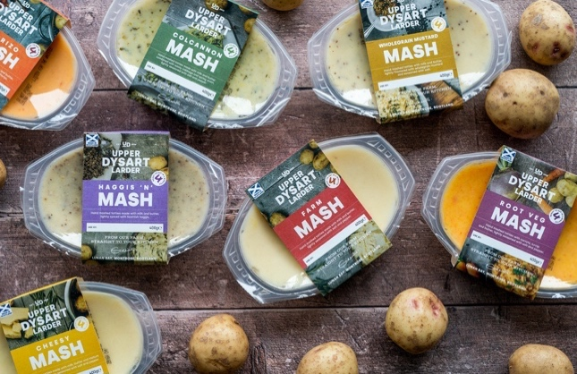

An enterprising potato farming family on the Angus coast has created a range of fresh no-fuss mash available to buy direct from the farm. This spring, the Stirlings at Upper Dysart Farm near Montrose are launching a series of nourishing, guilt-free convenience vegetable side dishes, grown, cooked and packed on their farm.

With emphasis on the taste and texture of home cooking, the Upper Dysart Larder mash comes in seven flavours, including traditional creamy farm mash, wholegrain mustard mash and mash with chorizo, and is available to buy direct from the farm’s “larder”. Sealed for freshness, without the need for preservatives, it cooks in under four minutes, whistling when it is evenly warmed through and ready to eat.

Andrew and Anita Stirling have farmed at Upper Dysart for 30 years and in 2008 Stirfresh was set up, for many years supplying fresh vegetables and fruit to schools and hospitals. Their four children, Alexander, Jessica, Hannah and James, have all returned to the farming business and together have launched Upper Dysart Larder.

The youngest sibling, James Stirling, makes the mash, and has spent many months perfecting the balance of ingredients for each flavour. He says convenience doesn’t need to mean highly processed/ with a greater consciousness around health, customers don’t want a long list of preservatives:

“Life is busy and sometimes it’s not easy to have the time to cook or eat as healthily as much as we want to. We wanted to create a high-quality, honest, home-style product that customers could fit into life, whether you are busy mum, hosting a dinner party or fuelling up at work. It’s guilt-free, wholesome convenience. We’ve sealed in the goodness of our potatoes from the farm for our customers to enjoy all of the natural nutrients and taste with none of the faff. Preserved naturally for longer, it also helps reduce food waste and make savings.”

The mash can be a meal in itself or to accompany other meat and vegetables and is a flagship for all Upper Dysart Larder’s vegetable sides and soup packs available to buy direct from the farm. Other products include baking potatoes and easy roast potatoes. The self-service farm vending machines will also sell other local produce from around Angus and beyond including Bon Accord juices, Galloway Lodge jams and chutneys and Fleming's steak pie.

In a beautiful coastal setting, visitors can enjoy a coffee when they come to buy from Upper Dysart Larder’s farm vending machines and visit the old airfield. Eldest daughter Jessica, who has masterminded the on-farm larder with the family, says:

“As well as making it super convenient and easy, we want buying from the vending machines and seeing the farm to be part of the experience, particularly for young children to encourage them to see and enjoy their vegetables in a different way. There will usually be someone from our family around to chat to and find out more about what we do here, and the Larder is close to plenty of lovely beach walks so you can make an outing of it.”

Upper Dysart Larder mash and other “easy veg” is also available to buy from local independent retailers and, from 7 April and while stocks last, in Aldi stores across Scotland.

/ENDS

Editor’s Notes
- Upper Dysart Larder www.upperdysart.co.uk
info@upperdysart.co.uk +44 (0)1674 677843
I:@upperdysart F: @upperdysart
- The Stirling family has been farming at Upper Dysart Farm, a 430-acre farm overlooking Lunan Bay, for four generations. Anita and Andrew Stirling took over the farm over 30 years ago, bringing up their four children and building the business. In 2008, they started Stirfresh, washing and peeling fresh vegetables for schools and hospitals to make fresh eating easy, and, in time, also suppling retailers with “easy veg”. Now all four of children have returned to the family business, and together they are launching Upper Dysart Larder, a range of quality fresh mash and, alongside this, a self-service farm “larder” selling their mash and local produce from around Angus to continue their mission to supply Scotland with fresh, quality and nutritious products.
- Upper Dysart Larder runs a community initiative, providing soup packs in the local community.
- The initial seven flavours - chorizo mash, wholegrain mustard mash, cheesy mash, haggis ‘n’ mash, colcannon mash, root veg mash and classic creamy farm mash
- Using cutting edge technology, the potatoes and other vegetables are gently cooked in the packaging, retaining both taste and nutrition. The packaging is designed to stack easily and avoid using unnecessary space on fridge shelves. It cooks in under four minutes in the microwave and whistles when the mash is evenly heated through and ready to eat – no cold spots. There is no need to pierce the film and, unopened, it keeps warm in the tray for 15-20 minutes after cooking.

