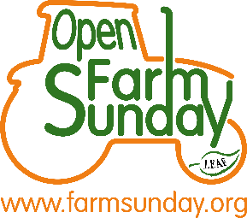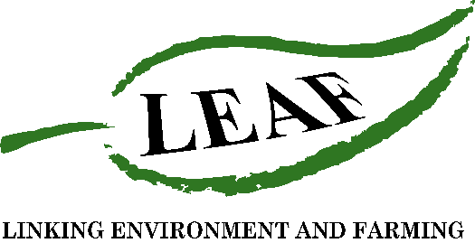
Press Release
*For immediate release*
How hungry is your soil?
Organisers of LEAF Open Farm Sunday, Linking Environment And Farming, are encouraging farmers to plant their cotton ‘pants’ now to demonstrate to visitors in June the importance of soil management in agriculture, and the role of microorganisms in maintaining its health.
This optional activity, is one of a number of ideas available to LEAF Open Farm Sunday (LOFS) host farmers to talk about this year’s theme “health”. The focus is on the health of soil, crops, livestock and biodiversity through to food, people and community.
Farmers wanting to get involved need to plant any 100% cotton items before Easter Sunday (17th April), and then dig them up on or just before LOFS on Sunday 12th June 2022. Over the next 60 days or more, at 8” deep, the lifeforms in the soil will begin eating the cellulose sugar, from which cotton is made, and start decomposing the organic material.
Sterile, lifeless soil will have little impact on the cotton, whereas organically thriving soil will result in very little to dig up, demonstrating a really healthy soil.
Annabel Shackleton, LOFS manager explained:
“All farmers, growers and crofters who take part in LEAF Open Farm Sunday have access to a wide range of free resources and activity ideas, aimed at sparking conversations and demonstrating to visitors the range of skills and work that farmers do. ‘Plant Your Pants’, is a fun way for farmers to talk about soil management, and the role it plays in climate health – from sequestering carbon, flood prevention and supporting biodiversity.”
The idea is not a new one, with farmers and school children in USA, Australia, New Zealand and more recently Switzerland, monitoring soil microbial activity by burying cotton pants!
LEAF Demonstration Farmer and AHDB Strategic Monitor Farmer Brian Barker, brought the concept to the UK after visiting Canada as part of his Nuffield Scholarship, and has shared the results of his own ‘plant your plants’ experiments on his social media channel @the_barker_boys.
Annabel added, “Soil is always a popular discussion topic with visitors on LEAF Open Farm Sunday, whether its digging for worms or looking at root structures in a soil pit. This plant your pants activity I’m sure will put a smile on everyone’s faces on the day! We are encouraging farmers to take photographs before and after they plant items to demonstrate the difference to visitors. We would love to see everyone who gets involved to write #LOFS22 on the cotton, and then upload a photo and post it on social media!”
For farmers inspired by this activity and wanting to take part in LOFS, it is free to register and farmers do not need to be a member of LEAF. Every farmer decides the type of event they want to host. A simple farm walk for an hour or so is a great way to start. A free online ticketing service is available to manage visitor numbers, and a series of Zoom meetings are scheduled to share top tips and answer farmers’ questions.
The next Zoom meeting, on Thursday 7th April at 7pm will touch on ‘plant your pants’ and other activities and resources available to help farmers share their story. To find out more and to register to take part in LEAF Open Farm Sunday, visit www.farmsunday.org.
For further information, a case study or to arrange an interview please contact Rebecca Dawes at Jane Craigie Marketing via rebecca@janecraigie.com or 07792 467730.

Editors’ notes:
- LEAF Open Farm Sunday is managed by LEAF (Linking Environment And Farming) - the leading organisation delivering and promoting Climate Positive action, thriving, resilient and exemplar agro-ecological farming at an increasingly global level. Working with farmers, the food industry, scientists, environmentalists, teachers, young people and consumers we are looking at new ways to deliver productivity and prosperity among our farmers, enrich the environment and engage young people and society in a valuable and meaningful way. LEAF set up and has managed LEAF Open Farm Sunday since it began in 2006 (LEAF is a registered charity no: 1045781)
- LEAF Open Farm Sunday 2022 will take place on 12th June. Register to host an event at www.farmsunday.org.
- Sponsors of LEAF Open Farm Sunday include: AHDB, Arla Foods, Asda, BASF, Co-op, Defra, Farmers Weekly, Frontier Agriculture, John Deere, LEAF Marque, NFU, Sainsbury’s, Tesco and Waitrose

