PRESS RELEASE
MARCH 2022

Slow travel not time travel with bespoke Outlander tours of Scotland
Celebrating the new series of Outlander

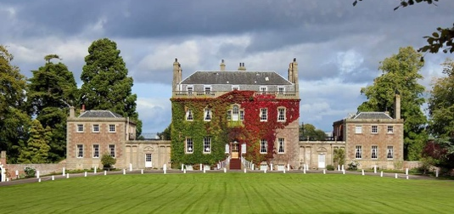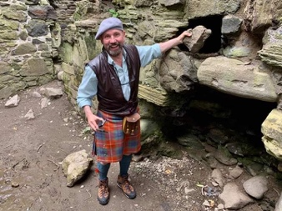

As series six of the hot time-travel drama, Outlander, hits our screens this month, Scotland’s bespoke travel operator, Spirit Journeys, celebrates with five Outlander tours around Scotland.
The popular guided trips, which have been running for five years, combine Scotland’s dramatic landscapes, ancient monuments and famous battlefields with warm hospitality in owner-run accommodation, local food and enriching stories from through the ages.

Each of the Outlander Tours is customised to the guests and is based on personal experience of the places. Julia MacLeay, who founded the travel company in 2015 and now has a team of six, has been offering responsible, sustainable tourism before it had an official name. She said:

“We want to give guests a really rich, cultural adventure and we intentionally stay a little longer in each place so that guests can really experience it and they don’t feel rushed. We are proudly ‘slow travel’. Staying in small hotels and eating in places locals recommend, seeing special sights that are not always in the guidebooks, it’s a very real experience all brought to life by the people they meet and the stories they hear. All of our tours are a chance for those visiting Scotland to navigate safely off the more beaten tourist trail and see its true colours.”
All accommodation and meals are hosted in small, owner-run places, offering guests an authentic insight into the local culture, whilst also supporting independent businesses.
What guests say:
“Just returned from an Outlander Tour. Everything was perfectly orchestrated, well organised with much appreciated personal touches. I would highly recommend Spirit Journeys.”

“Julia and her team think of every detail, and although it’s an utterly fulfilling trip, you are always left wanting more, which is as it should be and just an excuse to come back.”

Spirit of Outlander Tours (7-, 11- or 16-day guided group tour)
Experience a different side of Scotland’s spirited history and heritage. Inspired by Diana Gabaldon’s Outlander series, this tour combines Scotland’s ancient monuments, famous battlefields and landscapes with traditions and folklore. Accompanied by a guide, you will delve deep into legends and unearthed gems, from Loch Lomond, Glencoe and Loch Ness to the 4000-year-old stone circle, the Clava Cairns, which is said to have inspired the Diana Gabaldon novels, as well as castles, churches and villages famous for their distilleries. On the 16-day trip, you will cross the sea to Skye with sightings of the Old Man of Storr and Kilt Rock and on to the Isle of Lewis to learn about the ancient custom of weaving at the famous Harris Tweed shop. The trip is the ‘bells and whistles version’ and has a few surprises on the way as well as ending with a fantastic grand finale dinner.

Book now for August 2022 and August 2023:
7-day from £1999 per person (based on two people sharing)
11-day from £2999 per person (based on two people sharing)

16-day from £3999 per person (based on two people sharing)

Outlander Tour of Scotland (7-day guided tour)
Inspired by Diana Gabaldon’s Outlander series, this seven-day tour combines Scotland’s ancient monuments, famous battlefields and landscapes with traditions and folklore. Accompanied by a guide, you will delve deep into legends and unearthed gems, initially following the journey made by Claire Fraser in the first series, from Loch Lomond, Glencoe and Loch Ness to the 4000-year-old stone circle, the Clava Cairns. The tour also includes stately homes, villages famous for their distilleries and Scotland’s capital city, Edinburgh, with its rich history.

These 7-day tours run once a month. From £1499 per person (based on two people sharing)

Outlander Pod Abroad May 2022
Join Ginger and Summer of California’s Original Outlander Podcast for this exclusive 12-day Pod Abroad tour of Scotland. The grand tour of Scotland takes in landscapes, monuments and battlefields that feature so predominantly in Outlander, finishing with a grand finale dinner. Highlights include Loch Ness, Hopetoun House and the Clava Cairns where Claire travels through time, the site said to be what. inspired the novels. A must for all Outlander fans to see the sights and stories behind the historical drama.

17-29 May 2022. £2999 per person. For more details see: https://spiritjourneysworldwide.com/tours/outlander-pod-abroad-2021/#/

Day tour
Or enjoy an Outlander Day Tour in addition to another Spirit Journeys trip. This Outlander-inspired guided tour combines Scotland’s gripping history with some of the places portrayed in Diana Gabaldon’s books in and around the Highland capital of Inverness. Run from Inverness or Invergordon, it can be booked privately or by individuals. Maximum of 8 people.

See 7 reasons to join an Outlander Tour.

Spirit Journeys also offers bike, walking and cultural tours, each customised to guests and their priorities, any of which can be added on to the above tours or booked for another visit.

Editor’s Notes:
- Spirit Journeys Worldwide is a Scotland-based travel company registered with ATOL and the Travel Trust Association (TTA). With over 25 years of experience organising travel arrangements worldwide, it organises personalised travel in Scotland and across the world.
www.spiritjourneysworldwide.com
Facebook

