Discuss, debate, do….BSAVA’s Congress Programme is different

As details of the new programme, including the five Learning Zones, module titles and sessions, go online, BSAVA reveals the full extent of the programme’s shakeup.

Manchester Central, the event’s new venue, facilitated the move away from long format lectures. Instead, from 24-26th March 2022, delegates will be immersed in debates, discussions, dramas, interactive sessions and short-format lectures.

“Congress 2022 represents many firsts for BSAVA,” says President, Sheldon Middleton. “It’s the first hybrid event not just for the organisation but, I believe, the UK’s small animal veterinary community. It’s also the first time the event is being held in Manchester, and the first time we’ll have delivered CPD through the dramatisation of in-practice experiences.”

Designed to develop para-professional skills such as communications and time management, the ‘Day in the life of…’ dramas will, through role-play and discussion, also impart the latest clinical research. Each day will see actors explore a different scenario. On Thursday the focus is anaesthesia, Friday neurology and on Saturday, reproduction.

“The storylines have been chosen because they are both common and challenging in first opinion practice,” explains Programme Committee Chair, Paul Higgs.

This pragmatic approach underpins the programme which has been carefully designed to provide the highest quality, independent CPD for practice managers, veterinary surgeons and veterinary nurses.

“While we’re covering the usual range of disciplines, from orthopaedics and ophthalmology to cardiology and canine medicine, the programme reflects our growing understanding of how individuals learn best. There are plenty of opportunities to get involved, to test newly acquired knowledge and get hands on. For the first time, delegates will be able to drop in on practicals, at no further charge.

“And rather than streams, this year’s Congress has modules where the content builds. It’s still possible to dip in and out, but those that follow a module will find it flows from one session to the next. When it comes to making the most of what is on offer, delegates have a choice – they can either follow a module around Congress or pick their preferred learning style and stay in that relevant zone,” says Paul.

“As Congress has been streamlined to three, rather than four days, every session within the programme has had to justify it’s place. There’s no waffle, no nice-to-haves, no mediocre sessions. They all deliver. It’s very hard to pick out highlights.

“Having said that, as a European Veterinary Specialist in Small Animal Internal Medicine, I’m drawn to the feline medicine: infectious disease module. On Thursday, for example, you’ll find me in Feline Infectious Peritonitis session - there have been some interesting developments on treatment option and I’m keen to see how that relates to first opinion practice.”

BSAVA’s Programme Committee have been careful to avoid overlap and delegates can be free from fear of missing out with the online platform providing opportunities to catch-up on the lectures they couldn’t attend on the day.

“The hybridisation of Congress has multiple benefits. For those coming to Manchester, there’s also the opportunity to delve deeper into the subjects they’ve explored on the day. It adds a significant value to the cost of attending. That content is also available for any virtual attendees who can tap into the live streams, as well as the additional content,” explains Sheldon.

For more information about the programme visit: https://www.bsavaevents.com/bsavacongress2022/en/page/programme

NOTES TO EDITORS:

Images attached:

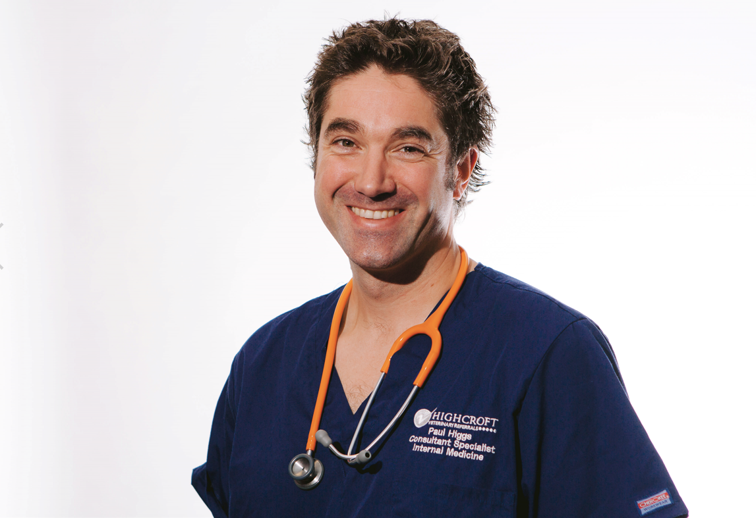

<insert image of Sheldon>

About Congress:

BSAVA Congress 2022 is a hybrid event taking place on Thursday 24th March – Saturday 26th March online and at Manchester Central. To find out more visit: https://www.bsavaevents.com/bsavacongress2022/en/page/home

Our thanks go to our industry partners which include:

Diamond
- VetPlus

Platinum+
- Vetoquinol
- Zoetis UK Ltd

Platinum
- IDEXX Laboratories Ltd
- ROYAL CANIN

Gold
- Burtons Medical Equipment
- Hill’s Pet Nutrition
- Orion Pharma Animal Health
- Summit Veterinary Pharmaceuticals
- Vets4Pets

Silver
- IVC Evidensia
- Vets Now
- IMS Euro
- Boehringer Ingelheim Animal Health
- TVM UK
- Technik Veterinary
- IMV Imaging
- Burgess Pet Care
- JAK Marketing
- DocsInnovent

Bronze
- BOVA UK
- NationWide Laboratories
- VetCT
- Protexin
- Orthomed/Infiniti
- Medimark Scientific
- Eickemeyer Veterinary Equipment Ltd
- Millpledge Veterinary
- Virtual Recall
- KARL STORZ Endoscopy (UK) Ltd
- Albert Waeschle
- iM3 Dental Ltd
- Nutravet
- Dechra Veterinary Products
- The Veterinary Defence Society
- KRUUSE UK Ltd

About BSAVA:

The British Small Animal Veterinary Association (BSAVA) is a professional membership association and registered charity, which exists to promote excellence in small animal practice through education, science, and community. Established in 1957 as an Association run by the profession, for the profession, the BSAVA is a not-for-profit professional body, and has a membership of more than 11,000 veterinary surgeons, vet nurses and students.

Contact BSAVA: PR & Communications Office, press@bsava.com or call 01452 726729. www.bsava.com

