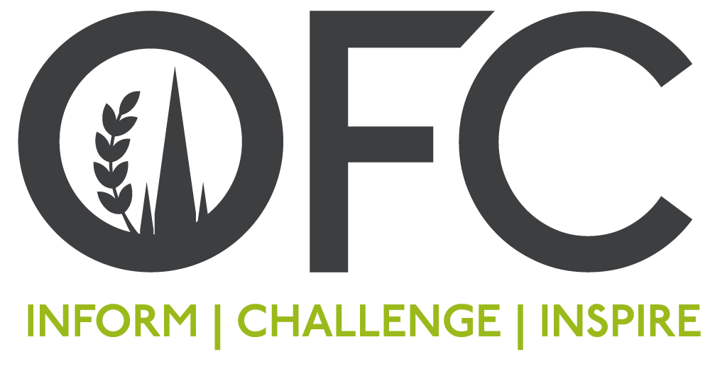

Press Release
10 January 2022

Dame Ellen MacArthur dazzles delegates on the final day of the Oxford Farming Conference
Known as the record-beating sailor who solo-circumnavigated the world, Dame Ellen MacArthur is now making waves with her charitable work centred on the circular economy. Speaking to delegates on the final day of the 2022 Oxford Farming Conference (OFC), Dame Ellen explained how circularity can align with food, farming and agriculture.
A circular economy decouples economic activity from the consumption of finite resources and Dame Ellen encouraged the audience to take greater interest in this resilient system, which is good for business, good for people and good for the environment.
“When you set off on a boat around the world, you take with you everything you need for your survival. That’s food, fuel, spare circuit boards and equipment, and when you leave for that two-to-three-month long journey, you manage everything you have and develop this overwhelming understanding of what it is to have finite resources.
“When I broke the record and set foot on the finish line it really hit me that, actually, our world is no different.”
Since leaving racing, Dame Ellen has committed herself to researching circular economies. In 2021, the Ellen MacArthur Foundation launched The Big Food Redesign report which explores the ways in which food products can be designed in closer collaboration with farmers, for nature.
“When you look at the economy today, it is a result of the industrial revolution. We take a material out of the ground, we make something out of it, and we throw it away. When we look at farming, we use vast amounts of chemical fertilisers to help us to grow the products and you could call that a linear system because you’re putting finite materials into that system, and a linear system is a race to the bottom. Circular economy changes everything because it’s a race to the top.
“We need to change the system, so it works better for nature, works better farmers, invests in the farmer’s land rather than degrading it, and is an end-to-end system that involves the farmer and the consumer.”
The Oxford Farming Conference welcomed more than 1,000 delegates virtually over three days who participated in a varied programme which included international speakers and sessions covering trade, politics, science, climate and technology, to name but a few.
Principal Sponsors of the OFC include Eden Search & Select, Fendt, Marks & Spencer, Savills, The Institute of Agriculture and Horticulture (TIAH), and the WWF and Tesco Partnership.
All sessions are available to watch back through OFC’s on-demand channel and can be access by purchasing a digital ticket via www.ofc.org.uk.
ENDS

