BSAVA Congress 2022 tickets go on sale

Tickets to Europe’s largest small animal veterinary event have gone on sale, with early bird discounts for those that register before 17th February 2022.

With a new structure to the programme, free practicals for onsite delegates, immersive “a day in the life of…” dramas, opportunities to meet speakers, social events and an extensive exhibition, BSAVA Congress 2022 is all set to ‘raise the bar’ in the world of veterinary events.

The event takes place on Thursday 24th March – Saturday 26th March at Manchester Central, delegates can also attend online, through an interactive virtual platform, which will run alongside the live event.

“As usual, Congress will provide veterinary professionals with the independent, comprehensive, practical CPD it is renowned for. It’s the ‘how’ that has changed,” says Sarah Fitzpatrick, BSAVA Head of Partnerships and Events. “Last year’s online event proved this can all be delivered in a much more interactive and engaging way. Returning to a face-to-face format enables us to take that even further and provide delegates with a truly immersive experience.”

Many sessions at this year’s event feature two speakers delivering different perspectives on a topic, followed by a Q&A. With just 15-20 minutes to get into the detail, lectures will get straight to the point, be fast-paced and rich in content. Extensive Q&As follow, giving delegates the opportunity to guide the direction of the discussion and ensure they get what they need from the event.

“The structure of this year’s programme is different to previous years,” explains programme committee lead, Paul Higgs. “Each subject will be delivered in a mix of formats, lectures, debates and interactive sessions, for example. It means delegates won’t find themselves sat for hours passively listening, instead they’ve the opportunity to actively engage with the topics, which will promote deeper learning.

“Where topics overlap subject areas, module delegates will come together to explore diagnostics, treatments and ethics.”

When pushed on his what-not-to-miss, he reveals that the feline infectious disease module will feature a session on TB and FIP. “There are some really exciting developments in this area, and we’re bringing the latest research to the floor at Congress. Like all the other sessions, it’ll still be focused on first opinion practice and what’s realistic and pragmatic for this setting.”

“A day in the life of….”, a new feature for the 2022 event, will see actors play out scenarios, with experts and the audience invited to discuss the options before returning to the actors to play out the scene. And, for the first time, Manchester’s delegates will be able to get hands-on in practical sessions at no further cost.

BSAVA’s President, Sheldon Middleton, said: “I can’t wait to get to BSAVA Congress in 2022. The new venue, new format and new exhibition layout will enhance everything that BSAVA Congress is known for. Now we’ve got a hybrid format, the on-demand feature means that for the first time I can catch up with friends and not miss the CPD!”

Alongside the extensive programme of CPD, the exhibition is filling up fast. VetPlus, global leaders in veterinary nutraceuticals, said: “We pride ourselves on the support we give to independent veterinary practices throughout the UK and internationally every day. As a long-time supporter of BSAVA, we are thrilled to announce ourselves as the Diamond sponsor for 2022, at the new venue in Manchester. As a proud, Lancashire based business, we look forward to meeting face to face with veterinary teams in Manchester and to support this fantastic educational event once again.”

Selected for its accessibility, support of innovation and vibrancy, the venue in Manchester has enabled the organisers to bring the whole of Congress under one roof. “As a city Manchester embodies much of what Congress is about,” explains Sarah Fitzpatrick. “It has a proud history in science, as well as politics, music, arts and sports. It combines its extensive heritage with a progressive vision to be a city that delivers surprise and delight in equal measure.

“With great transport links, a wide range of hotels as well as world-renowned restaurants, we hope delegates will find Manchester a convenient yet inspiring location for Congress. I’m looking forward to welcoming professionals from across the small animal veterinary sector this March.”

To purchase your tickets visit: https://www.bsavaevents.com/bsavacongress2022/en/page/home.

-ENDS-

NOTES TO EDITORS:

Images attached:

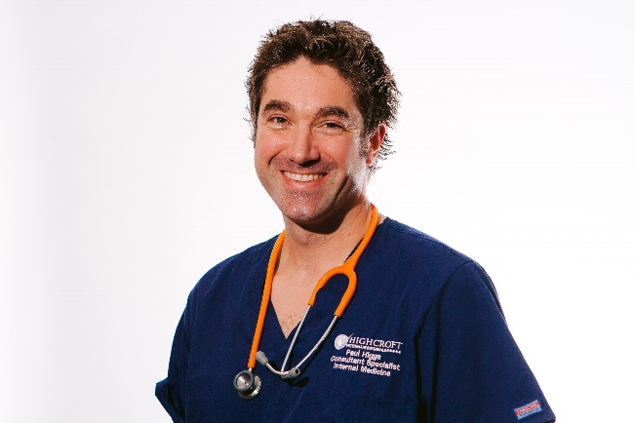

<insert pictures of Sarah and Sheldon>

About Congress:

BSAVA Congress 2022 is a hybrid event taking place on Thursday 24th March – Saturday 26th March online and at Manchester Central. To find out more visit: https://www.bsavaevents.com/bsavacongress2022/en/page/home

Our thanks go to our industry partners which include:

Diamond
- VetPlus

Platinum+
- Vetoquinol
- Zoetis UK Ltd

Platinum
- IDEXX Laboratories Ltd
- ROYAL CANIN

Gold
- Burtons Medical Equipment
- Hill’s Pet Nutrition
- Orion Pharma Animal Health
- Summit Veterinary Pharmaceuticals
- Vets4Pets

Silver
- IVC Evidensia
- Vets Now
- IMS Euro
- Boehringer Ingelheim Animal Health
- TVM UK
- Technik Veterinary
- IMV Imaging
- Burgess Pet Care
- JAK Marketing
- DocsInnovent

Bronze
- BOVA UK
- NationWide Laboratories
- VetCT
- Protexin
- Orthomed/Infiniti
- Medimark Scientific
- Eickemeyer Veterinary Equipment Ltd
- Millpledge Veterinary
- Virtual Recall
- KARL STORZ Endoscopy (UK) Ltd
- Albert Waeschle
- iM3 Dental Ltd
- Nutravet
- Dechra Veterinary Products
- The Veterinary Defence Society
- KRUUSE UK Ltd

About BSAVA:

The British Small Animal Veterinary Association (BSAVA) is a professional membership association and registered charity, which exists to promote excellence in small animal practice through education, science, and community. Established in 1957 as an Association run by the profession, for the profession, the BSAVA is a not-for-profit professional body, and has a membership of more than 11,000 veterinary surgeons, vet nurses and students.

Contact BSAVA: PR & Communications Office, press@bsava.com or call 01452 726729. www.bsava.com

