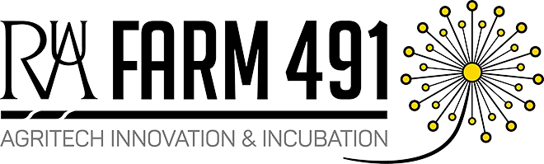

Press Release
21.09.21

Farm491 set to host a series of webinars exploring UK agriculture state of affairs
Farm491, part of the Royal Agricultural University (RAU), is set to host a series of three webinars exploring the current policy landscape, market trends, and challenges within UK agriculture.
Over the coming weeks, leading academics will delve into their specialist areas to explain how agricultural practices have evolved, the potential innovations that can take place and the obstacles that we might encounter along the way.
Speaking about the purpose of the webinars, Verity Payne, Farm491’s Centre and Events Manager, said that:
“This series is intended to provide an oversight to those businesses who are thinking about launching, diversifying or growing into the agricultural and land management sector to help them better understand their business customers and discover where opportunities might lie, both now and in years to come”
The series will commence on 29th September with a session on ‘Global and Local Opportunities for Higher Animal Welfare’ and will be delivered by Professor David Main, Professor of Production, Animal Health and Welfare at The RAU.
The second will be held on 6th October, where Crop Production and Agronomy Lecturer Adam Hinchcliffe will discuss ‘Policy, Challenges and Opportunities in Arable Farming’.
The series will culminate on 20th October when Professor Louise Manning, Professor of Agri-food and Supply Chain Production and Director of Knowledge Exchange at The RAU will address ‘The Complexities of Championing Integrity in Food Supply Chains’.
Farm491 has supported 200 start-ups and has over 70 members which they bring together in a unique incubation space and hub. The unit which is part of the Royal Agricultural University is dedicated to tech start-ups focused on agriculture, horticulture, food and environmental sustainability.
Find the specific event details and purchase tickets at https://www.eventbrite.co.uk/o/rau-farm491-15772300634. The sessions are free to Farm491 members and cost £12 per session for non-members. Sessions can be listened to live, or recordings can be provided. If you are a Farm491 member please contact Verity (verity.payne@rau.ac.uk) to obtain your ticket FOC.
-ENDS-
321 words

Notes to editors
Farm491 is a UK based leading technology incubator and innovation space focused on the future of farming and food systems. Based and owned by the Royal Agricultural University we work with entrepreneurs through all their stages of growth, leveraging our unique network of academic, industry and farming contacts and in house experts to help companies achieve their aspirations. This is primarily achieved through strategic advice, support raising investment, finding the right talent to build the team, access to new customers and being part of a network of other entrepreneurs. Farm491 is also involved in local and national policy on AgriTech and works with national and international partners to help reduce the fragmentation in the UK innovation ecosystem.
www.farm491.com

