BSAVA announces new format for Congress 2022

BSAVA has announced that their annual Congress will be held as a hybrid event for 2022.

The live event is due to be held on Thursday 24th March – Saturday 26th March in Manchester, with the opportunity for delegates to also attend online through an interactive virtual platform which will run alongside the live event.

Delegates who set foot in the venue are promised an experiential journey with immersive CPD, interactive sessions, practicals, debates and opportunities to meet speakers, all included in the package, according to the newly-formed programme committee.

“The new venue provides an opportunity to really shake up the content,” says BSAVA’s new congress programme committee chair, Paul Higgs. “It’s the first time BSAVA Congress delegates will have met in two years and we want to deliver an unforgettable experience.”

“We’ve thought long and hard about what delegates want and need, as well as the way people like to learn, integrating those approaches within the programme. Delegates will find few long-format lectures, instead there will be lots of opportunities to participate, to discuss, to do and to experience.”

Paul Higgs is a recognised European Veterinary Specialist in Small Animal Internal Medicine and the clinical director of Highcroft Veterinary Referrals in Bristol. He spent many years in first opinion practice and BSAVA’s Congress has been pivotal in his continued professional development throughout his career. Chairing the programme committee, he says, is his way of supporting the profession.

Paul continued: “For general practice vets and nurses, we’re offering an immersive experience designed to support the skills required in first opinion practice yet rarely provided in a lecture alone. And while the CPD will provide ample opportunity to learn about the clinical aspects, delegates will also have the opportunity to immerse themselves in true-to-life case management events in a dedicated space to help reflect those paraprofessional skills that are so critical to first opinion practice.”

Visitors will also find the latest products and services on show at the exhibition with industry-leading organisations such as Vet Plus, Summit Veterinary Pharmaceuticals, Orion Pharma Animal Health and Boehringer Ingelheim Animal Health among the long and growing list of industry partners to confirm support of this year’s event.

Alongside industry partner stands’, delegates will be able to drop-in to practical sessions and perfect a technique such as undertaking cytological examination, reading radiographs and even performing endoscopy in as little as 15 minutes. For the first time, the practical sessions will be included within the ticket price. “Honing physical skills is something that can only be done in person, yet is essential to our daily life in practice,” notes Paul.
Last year’s delegates relished the opportunity to pick-the-brains of speakers with some conversations flowing for hours in the online chat rooms. BSAVA is bringing this successful format to the event in Manchester, giving delegates the opportunity to meet the speakers in a dedicated space in the exhibition during lecture breaks.
“While some of the finer details for the programme are still to be revealed, the major themes have already been confirmed,” says Paul. “In feline medicine, for example, we’ll be covering infectious diseases, and in the cardiac stream, thrombotic disease will be a key topic. We will be announcing more details when tickets go on sale next month,” he teases.

Although some sessions will be more aligned to nurses, all sessions will be open to all professions. “Nurses are increasingly looking for opportunities to expand their knowledge, horizons and skillsets, while many vets want to, and would benefit from, learning from our excellent nurses. The programme will reflect this.” Likewise, BSAVA programme committee are incorporating aspects of practice management within the programme.

“Vets and nurses aren’t isolated from the fact practices are businesses and the decisions they make have a financial impact,” he says. “Everyone in the profession has something to give and BSAVA Congress 2022 is a chance for everyone to come together to hear people you’ve never heard before, see things you’ve never seen and do things you’ve never done.”

Tickets will be on sale late October. To find out more visit: https://www.bsavaevents.com/bsavacongress2022/en/page/home.

-ENDS-

NOTES TO EDITORS:

Images attached:

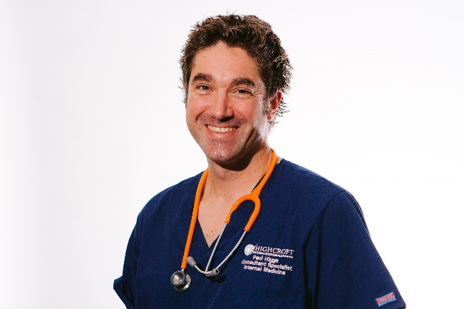

About Congress:

BSAVA Congress 2022 is a hybrid event taking place on Thursday 24th March – Saturday 26th March online and at Manchester Central. To find out more visit: https://www.bsavaevents.com/bsavacongress2022/en/page/home

Our thanks go to our industry partners which include:

- VetPlus
- Summit Veterinary Pharmaceuticals
- Orion Pharma Animal Health
- IMS Euro
- JAK Marketing
- Boehringer Ingelheim Animal Health
- IVC Evidensia
- BOVA UK
- NationWide Laboratories
- Protexin
- Orthomed/Infiniti
- Medimark
- Eickemeyer Veterinary Equipment Ltd
- Millpledge Veterinary
- Virtual Recall

About BSAVA:

The British Small Animal Veterinary Association (BSAVA) is a professional membership association and registered charity, which exists to promote excellence in small animal practice through education, science, and community. Established in 1957 as an Association run by the profession, for the profession, the BSAVA is a not-for-profit professional body, and has a membership of more than 11,000 veterinary surgeons, vet nurses and students.

Contact BSAVA: PR & Communications Office, press@bsava.com or call 01452 726729. www.bsava.com

