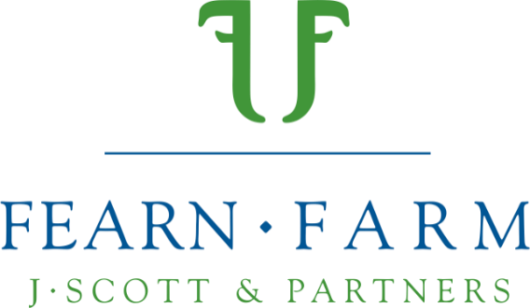
Press Release
10.08.21

Spotlight shines on Aberfield’s for ‘Great from Grass’ 10th Anniversary Sale at Fearn

Innovative livestock farmers, the Scott family of Fearn Farm, Ross-Shire, are set to hold their annual “Great from Grass” breeding sheep sale on Friday 27th August. Up for auction will be 160 rams, 350 gimmers and a larger than usual selection of Aberfield rams, with the entire crop being sold on the family’s farm for the first time in the sale’s 10-year history.

John and Fiona have been collaborating with Innovis, a leading supplier of sheep-breeding technologies to the UK livestock industry since 2014, and Aberfield rams have been thriving at Fearn since then. John’s goal has been to develop a high-quality flock that flourishes on a forage-based diet.

Having been keen to experiment with new genetics and to standardise his flock, John was initially drawn to Innovis for the data they were producing through their rigorous performance recording.

Dewi Jones, CEO of Innovis maintains that: “It is all about performance. It's about using two breeds initially and harmonising them and stabilising the cross, recording their performance in a commercial system and selecting quite hard within that to make sure that there's functional sheep that deliver for farmers.”

John says: “Our working relationship with Innovis has grown and, together, we have worked hard to develop an understanding which allows us to produce Aberfield rams which thrive all over Scotland.”

The Fearn Aberfield nucleus flock of 400 ewes, averaging 75kg at tupping, scanned at 182% this year. With less than 5% of lambs needing any assistance at lambing they get off to a flying start, averaging over 300 g/day to 8 weeks and go on to produce good, well-muscled carcases.

John is the only Innovis Aberfield breeding partner in Scotland and Dewi Jones highlighted the importance of the relationship, saying:

“John’s a long way away from us in Aberystwyth, so it’s useful for us to have a foothold in the north of Scotland with somebody that’s got such a good reputation.

We’re really passionate about improving the whole sheep industry and giving others a chance to help us on that journey.”

Following the success Fearn had in 2020 using the online Helmsman auction system for their ‘Yourbid’ ram sale, it will be adopted again for the upcoming Fearn Sale. Yourbid provides seamless integration of in-person and online bids through one platform, with John maintaining that it reduces the stress on the animals, and allows those bidding from afar to get involved without spending the day in the car. Ultimately, the system allows buyers to view the animals via pre-recorded videos, review all their EBV data and place bids from home, should they wish.

Despite Covid-19 restrictions, the Scott family is looking forward to this highlight in their farming calendar and providing an engaging environment for potential buyers. Acknowledging the importance of achieving a reasonable return, John also states the social aim of the sale.

“We want to put on an event to get people together, to chat and have a beer and just have that social experience, which is what we really missed last year.”

The partnership between Fearn Farm and Innovis is one that has resulted in the continuous improvement of the Aberfield flock to a standard which is renowned across the country. At the heart of the Fearn offering is service, both before and after sales, and this is something John and the rest of the team stand by.

The Yourbid sale will go live on 18th August 2021 with prospective buyers being able to visit the farm on 20th August to view stock. NZ Suffolks, Texels, Sufftex and Beltex will all be featured on 27th August, with Fearn Aberfields remaining exclusive to this sale.

To view the sale, visit https://www.yourbid.org/great-from-grass-2021.

-Ends-

For more information, to arrange an interview with John or Dewi, or request further photographs, please contact Rose Moggach via rose@janecraigie.com.

