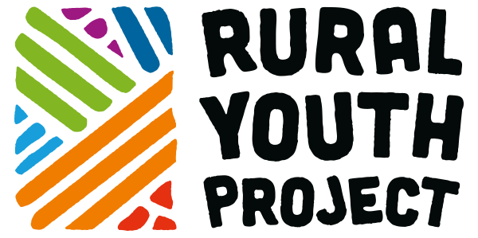

Press Release
For immediate release
World first youth dedicated Smart Village has launched in Scotland

A partnership between the Rural Youth Project and Smart Village Scotland has witnessed the successful launch of a pioneering, youth-centric Smart Village which will champion young people to collaboratively build vibrant, creative, and sustainable rural economies in the places they call home.

Smart Villages, a concept driven by the European Network for Rural Development, are rural digital ‘villages’ that combine physical and digital communities to improve their resilience, building on local strengths and opportunities. As such, the Rural Youth Project Smart Village now functions as a space where young people across Scotland can access helpful resources, connect with others, uncover employment and volunteering vacancies, and have their voice heard.

The platform, which is dedicated to tackling issues facing rural young people exclusively, is funded by LEADER (‘Liaison Entre Actions de Développement de l'Économie Rurale’. Attending the launch was Jackie Britton, who spoke on behalf of the programme which is dedicated to funding rural development efforts.

Ms Britton emphasised the programme’s delight at supporting such an initiative, especially since young people have been so disproportionately affected throughout the pandemic:

“The Rural Youth Project Smart Village fulfils all of the requirements we look for when considering funding. It has certainly been community-led; it has been a brilliant example of cooperation; and it is absolutely about innovation. It is truly pioneering.”

The existence of the Rural Youth Project Smart Village would also not have been possible without the involvement and guidance of young people themselves, known as Digital Champions. Representing the group who worked to design and populate the website, Amber Maslen (__) first highlighted the unique and often challenging position youngsters with rural backgrounds are in:

“It has been super inspiring to be part of a group of people who all want the same thing, and to be working to combat the gaps in information that have, in the past, made it difficult to be a young person in rural Scotland looking to start a business or a career.

We decided on the areas that would be most valuable to our peers, professionally and personally, before cultivating resources that would inspire, educate, and make life seems slightly less overwhelming.”

The launch of the Rural Youth Project Smart Village is a shining example of what can be achieved when individuals and groups come together for greater good, and has come at a time when collaboration and support are more important to rural life than ever before.

Whether you are a young person keen to set up your own profile, an organisation looking to share opportunities on the site, or a business with an exciting story to tell, the extensive and unique display of features provide means for wide-ranging rural success. To join the growing network, head to https://rypsv.com.

ENDS

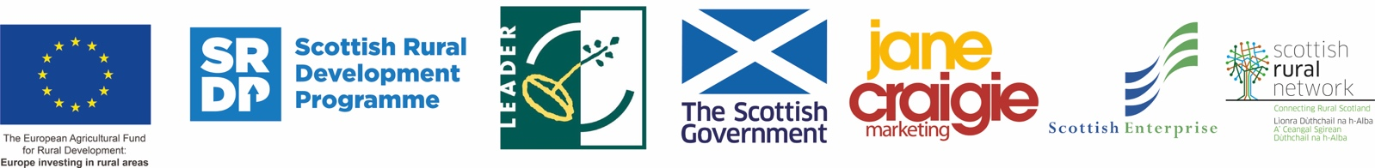

Notes to editors
- About the Rural Perth and Kinross LEADER Fund
The new LEADER, (‘Liaison Entre Actions de Développement de l'Économie Rurale’), Rural Development programme for Perth and Kinross was launched on Thursday 14 January 2016. Approximately £3.8 million of EU and Scottish Government SRDP (Scottish Rural Development Programme) funding is being invested in the local area between 2014 and 2020, bringing a boost to communities and the rural economy.

The funding will be directed towards the priorities identified in the Rural Perth and Kinross LEADER Programme Development Strategy and Business Plan, with the aim of helping to create a long-term legacy of vibrant, healthy and inclusive rural communities. The priorities include Community Capacity Building, Rural Broadband, Youth Initiatives, Farm Diversification, Rural Enterprise and there are Open Challenge and Co-operation Projects Funds also.

Funding is allocated by the Rural Perth and Kinross Local Action Group, (LAG). This independent body consists of representatives from local businesses and public sector and third sector organisations.

Anyone can apply: www.PKLeader.org , Facebook @PerthKinrossLEADERFunding, Twitter @P_KLeader #PKLeader

- About the Rural Youth Project
Established in early 2018 by communications and marketing professionals Jane Craigie and Rebecca Dawes, this research-based project aims to develop feasible strategies to facilitate the involvement of young people in agricultural and rural activity by better understanding their current situation, aspirations, opportunities and challenges. The international grassroots movement for positive change has a mission to empower young people (18 to 28 years of age) to develop their leadership, enterprise & activism skills, to play an integral part in making rural places attractive and viable for young people to build their lives and their futures there.
The project is creative in how it works, using Ideas Festivals and workshops, story seeking and telling and sharing the voices of young people. It also fosters international relationships and learning via learning journeys and joint events with other nations.
Ultimately the project wants to better understand young rural people, intergenerational links and to stem the outflow of vibrant young people from rural places.
The Project is about developing human-centric creativity, it is about learning from young people who can reimagine the future of rural places and it is about true collaboration.
Website: www.ruralyouthproject.com Email:hello@ruralyouthproject.com
Facebook/YouTube: Rural Youth Project Twitter/Instagram:@RYP2018

- For further information, images and interviews, please contact:
Rebecca Dawes - Rural Youth Project - hello@ruralyouthproject.com or 07792 467730

