xarvio™’s feature list is growing | 04/05/21
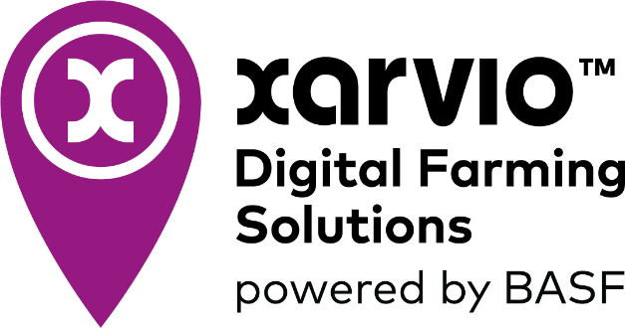

- Spring barley added to list of crop types available with enhanced features such as disease risk predictions, growth stage forecasting and alerts.
- Field notes – take note or a picture of a weed and app precisely records location by dropping a pin on a satellite map along with the day and time recording. These notes can be shared with others on the farm.
- ‘Management zones’ – marks out environmental areas and automatically prevent input applications when variable rate applications are used.
BASF Digital Farming announces multiple new features, available today, for users of xarvio’s FIELD MANAGER.
Growers can look forward to: ‘Buffer Zones’, maps that automatically prevent nutrient applications where risk of run-off and/or leaching is high; the ability to run and assess on-farm trials; and, more advanced integration of crop management solutions.
Meanwhile, spring barley now has enhanced features such as disease risk predictions, growth stage forecasting and alerts. ‘Management Zones’ allow the protection of environmental strips, and the new ‘Field Notes’ feature allows growers to accurately record, image, and pinpoint the location of issues, such as weeds, in any given field.
“It’s really exciting how quickly xarvio is developing,” says BASF’s Solutions and Services Market Manager, Louis Wells. “And it’s all based on user feedback, meaning the new features are practical to use and add real value to farming businesses.”
In Europe, xarvio FIELD MANAGER supports decision making across more than 45,000 farms, encompassing a combined total of more than 3 million hectares of arable land. It was launched in the UK in January 2020 and its user base is growing rapidly, more than doubling since summer 2020 from 1,100 to 2,500 users.
One such user is David Hurn, a farmer based in Norfolk. In collaboration with neighbouring farm, D.S. Means Ltd he grows root vegetables and combinable crops and tried xarvio FIELD MANAGER for the first-time last year.
“I knew I needed to start digitising my business and was looking for a suitable platform; something cost effective that would add value but wouldn’t require duplicating data input. After doing a lot of research around the options I chose xarvio. It’s comprehensive, easy-to-use and has good cross terminal compatibility, making it ideal for smaller farming businesses like mine.”
Mr Hurn has linked FIELD MANAGER to his two Arable Lab weather stations and has used it, so far, to plan crop input timings on a field of winter wheat. “We’ve found the disease and growth stage forecasts to be very accurate,” he says. “If all goes to plan, we’ll be using the new variable seed rate functionality, together with the crop protection.”
Mr Hurn is also a fan of the xarvio SCOUTING app.
“I’m using the SCOUTING app whenever I’m out crop walking to help identify and record weeds and diseases in my crop. I can bring across this digitised information from SCOUTING into FIELD MANAGER to help me plan my crop protection applications. Going forward this sort of information is almost certainly going to be required to justify the use of crop protection products and for fulfilling criteria around traceability and IPM.”
While FIELD MANAGER and SCOUTING are simple and intuitive to use for growers and advisors, up in the cloud there’s over 2.5 petabytes of data and 150 different models driving the delivery of precise in-field agronomic insights.
“‘Deep learning’ and ‘artificial intelligence’ are not buzzwords; they are what drive our phenology models and buffers zones concepts,” explains Bjorn Kiepe, head of agronomy, xarvio.
“At the start of the season we ask growers for very little information – field boundaries, crop type, yield expectations, variety, planting dates, and, in some cases, management practices. We merge this with our own data including satellite information, like biomass maps, soil maps, high-density weather data and infection case data. It’s this data partnership, a flow of information in both directions, that is so powerful in delivering great agronomic information for use in decision-making. With layers of information at their fingertips growers are empowered to create their own data-driven insights.”
The future for xarvio according to Mr Kiepe, lies in ‘data cubes’ and the multi-dimensional analysis. Data can be sliced, diced, aggregated and pivoted, enabling deeper analysis and for growers, more advanced and integrated crop management.
xarvio FIELD MANAGER can be accessed on the computer, and on the FIELD MANAGER app. The xarvio SCOUTING app is also available for free from the App Store and Google Play. For more information about xarvio Digital Farming Solutions, please visit www.xarvio.com.
Receive the latest press releases from BASF via WhatsApp on your smartphone or tablet. Register for our news service at basf.com/whatsapp-news.
About BASF Digital Farming GmbH
BASF Digital Farming is at the forefront of the digital transformation of agriculture, optimizing crop production. It’s xarvio™ Digital Farming Solutions brand offers digital products based on a global leading crop modelling platform, which delivers independent, field-zone-specific agronomic advice that enables farmers to produce their crops most efficiently and sustainably. xarvio products SCOUTING, FIELD MANAGER and HEALTHY FIELDS are being used by farmers in more than 100 countries. xarvio FIELD MANAGER is used by 48,000 farmers (total area of more than 5 million ha) in 17 countries, and xarvio SCOUTING is used by more 4 million farmers and consultants. For more information please visit xarvio.com or any of our social media channels.

About BASF’s Agricultural Solutions division
With a rapidly growing population, the world is increasingly dependent on our ability to develop and maintain sustainable agriculture and healthy environments. Working with farmers, agricultural professionals, pest management experts and others, it is our role to help make this possible. That’s why we invest in a strong R&D pipeline and broad portfolio, including seeds and traits, chemical and biological crop protection, soil management, plant health, pest control and digital farming. With expert teams in the lab, field, office and in production, we connect innovative thinking and down-to-earth action to create real world ideas that work – for farmers, society and the planet. In 2020, our division generated sales of €7.7 billion. For more information, please visit www.agriculture.basf.com or any of our social media channels.
About BASF
At BASF, we create chemistry for a sustainable future. We combine economic success with environmental protection and social responsibility. More than 117,000 employees in the BASF Group work on contributing to the success of our customers in nearly all sectors and almost every country in the world. Our portfolio is organized into six segments: Chemicals, Materials, Industrial Solutions, Surface Technologies, Nutrition & Care and Agricultural Solutions. BASF generated sales of €59 billion in 2019. BASF shares are traded on the stock exchange in Frankfurt (BAS) and as American Depositary Receipts (BASFY) in the U.S. Further information at www.basf.com.

xarvio™ is a trademark of BASF

