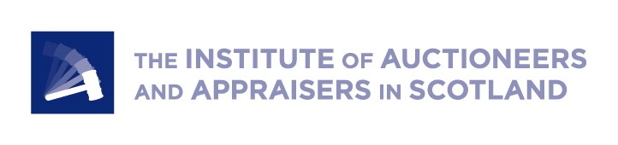
Livestock marts will be “rocks” during Brexit uncertainty

With less than four months until the end of the Brexit transition period, and still no clarity on a future relationship, livestock marts say they will be ‘rocks’ for farmers through the uncertainty.

For producers, every outcome will have a big impact – the new UK-EU relationship, non-EU trade agreements, and post-Brexit agri-environment schemes.

Livestock farmers are particularly vulnerable to trade disruption: Twenty-six percent of Scottish lamb sales and 6% of Scottish beef sales are exported, the majority to the EU.

“As auction marts, our business is perhaps not as exposed to the changes ahead as many, since we neither employ large numbers of migrant workers, nor deal directly with the export trade,” said Neil Wilson, Executive Director of the Institute of Auctioneers and Appraisers in Scotland (IAAS).

“We are, however, keenly aware of the possible impacts on our customers, and as auction marts we plan to be a rock of certainty for our customers, on what will likely be a bumpy road ahead.

“We will continue to work hard to sell their stock and achieve the most transparent, fairest and best prices – and to provide a community hub where they can share thoughts, news, knowledge and possibly worries.

“Our auctioneers will still be out on farm - Covid allowing- or at the end of a phone, offering a professional ear and sounding board.”

IAAS will also continue to lobby hard, said Mr Wilson:

“Few organisations talk to so many farmers on a regular basis. We will continue to use this unique insight to amplify farmers’ voices in parliament - both in Edinburgh and London. Because the job of Brexit is far from done, and soon the hard work of detailed policy building really begins.”

One example, said Mr Wilson, was the sheep producers’ support scheme in the event of a no-deal Brexit. Currently, two versions of the scheme are on the table – one that would support prime lambs at the point of slaughter, and the other that would support breeding ewes.

“We are urging government to ensure that these schemes are fair and straightforward for all involved and that any support makes its way, in full, directly to the primary producers, so that it is not used to subsidise other parts of the chain,” said Mr Wilson.

IAAS is also continuing to pressure government to enable trade between Scotland and Northern Ireland to continue as normal, rather than with the added burden of export health certificates.

As part of the Food Resilience Group, IAAS also working to ensure producers aren’t taken advantage of in future trade deals, and that the quality of Scottish produce is valued for its high welfare and low environmental impact compared to some global products.

“So whatever comes down the tracks in the next few months, lean on us, talk to us, because your local mart has your back,” said Mr Wilson.

[ENDS]

Notes to Editor

About IAAS
- The Institute of Auctioneers and Appraisers in Scotland (IAAS) is the representative body for livestock markets, valuers and auctioneers across Scotland. We fight for the interests of those markets and the central role they play in the working of the rural and agricultural economy. www.iaas.co.uk

