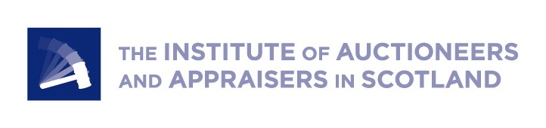
PRESS RELEASE
2nd September 2020
New President for Institute of Auctioneers and Appraisers

Donald Young, Group Director of United Auctions, has been appointed as the new President of the Institute of Auctioneers and Appraisers (IAAS). As well as 12 years on the IAAS board, he brings with him 34 years of continuous experience of working in livestock auction to this key role.

Mr Young was part of a management buyout at United Auctions, Scotland’s largest livestock auctioneers, four years ago, and plays an integral part in the daily management of the company as well as selling livestock on a weekly basis. He said of his new appointment:

“During these challenging times of the Covid-19 pandemic and the extra pressures of maintaining a physical distance in line with Scottish Government guidance, it has never been more important that we keep trade functioning as livestock values climb. Auction markets remain the most open, fair and efficient way of getting livestock to the right customer and achieving the maximum possible values.

“I look forward to working with our Executive Director Neil Wilson and the Board of IAAS to ensure the strength and integrity of our industry continues to increase.”

IAAS is the representative body for livestock markets, valuers and auctioneers across Scotland. It works continuously with politicians, governments and industry bodies to influence regulations and best practice for the benefit of Scotland’s farming industry.

Mr Young takes over the presidency from Scott Donaldson of farmstock auctioneers and valuers, Harrison and Hetherington in Carlisle. Neil Wilson, Executive Director of IAAS, said:

“Strong leadership is more important than ever in uncertain times and we are delighted to welcome Donald to his new role. He has many years of hands-on experience to help us navigate this unusual period and beyond. We would also like to thank Scott Donaldson for all his diligence and hard work over the years, and not least throughout the pandemic, when the Institute has remained committed to supporting the livestock trade to continue, implementing guidance and measures to support the individual marts for the benefit of our members, the supply chain and the rural economy.”

As well as raising awareness of the crucial role of livestock markets in Scotland’s rural and agricultural economy, IAAS sets an industry code of conduct, in particular for guaranteeing transparency in securing the best price and payment for all involved.

/ENDS

—————

For press enquiries and interviews please contact

Susannah at Jane Craigie Marketing susannah@janecraigie.com or 07841 194 897

About IAAS
The Institute of Auctioneers and Appraisers in Scotland (IAAS) is the representative body for livestock markets, valuers and auctioneers across Scotland. We fight for the interests of those markets and the central role they play in the working of the rural and agricultural economy. www.iaas.co.uk

